A Major Project Phase II Report on
ACCURACY-ADAPTIVE SPINTRONIC ADDER FOR IMAGE PROCESSING APPLICATIONS

Submitted
In partial fulfillment of the requirements for award of degree of
BACHELOR OF TECHNOLOGY
IN
ELECTRONICS AND COMMUNICATION ENGINEERING
By
E. JOHN MOSES 22W95A0405

Under the Esteemed Guidance of
Mr. D. NARASIMHA
Asst. Professor, ECE
Jawaharlal Nehru Technological University, Hyderabad


DEPARTMENT OF ELECTRONICS AND COMMUNICATION ENGINEERING MALLA REDDY INSTITUTE OF ENGINEERING AND TECHNOLOGY
(UGC AUTONOMOUS)
(Sponsored by Malla Reddy Educational society) (Affiliated to JNTU, Hyderabad)
Maisammaguda, Dhulapally post, Secunderabad 500014
2024-2025

DEPARTMENT OF ELECTRONICS AND COMMUNICATION ENGINEERING
CERTIFICATE

This is to certify that the Major Project Phase II entitled “ACCURACY-ADAPTIVE SPINTRONIC ADDER FOR IMAGE PROCESSING APPLICATIONS” that is being submitted by E. JOHN MOSES (22W95A0405), under the guidance of Mr. D. NARASIMHA for the award of B.Tech Degree in ELECTRONICS AND COMMUNICATION ENGINEERING from the MALLAREDDY INSTITUTE OF ENGINEERING & TECHNOLOGY, Maisammaguda (Affiliated to JNTU Hyderabad) is a record of Bonafide work carried out by them under our guidance and supervision. The results embodied in this major project phase 1 have not been submitted to any other university or institute for the award of any degree.

Project Guide HOD

Mr. D. NARASIMHA

Department of ECE

External Examiner Principal
Dr. P SRINIVAS


DECLARATION

I, E. JOHN MOSES (22W95A0405), hereby declare that the major project phase II entitled “ACCURACY-ADAPTIVE SPINTRONIC ADDER FOR IMAGE PROCESSING APPLICATIONS” is Bonafide work done and submitted under the guidance of Mr. D. NARASIMHA in partial fulfilment of the requirements for the award of the degree of BACHELOR OF TECHNOLOGY in ELECTRONICS AND COMMUNICATION ENGINEERING.

DEPARTMENT OF ECE

E. JOHN MOSES | 22W95A0405

ACKNOWLEDGEMENT

I am very much thankful to Director, Shri. P.PRAVEEN REDDY for giving us this opportunity to do this major project phase1. We express our deep sense of gratitude to him for his constant guidance and inspiring words.

I express our profound thanks to our Principal, Dr. PORANDLA SRINIVAS, for extending all the college facilities for the completion of the major project phase II.

I would like to thank Mr. OWK. SRINIVASULU, (Ph.D), Associate Professor and Head of the Department of Electronics and Communication Engineering for having provided the freedom to use all the facilities available in the department, especially the laboratories and the library, at any time.

I feel highly obliged to our major project coordinator Mr. S. RAMESH BABU, Associate Professor and project guide Mr. D. NARASIMHA, Assistant Professor, Department of Electronics and Communication Engineering for their constant encouragement and moral support. They have been a source of valuable guidance, suggestions and kindness during the course of the project work. We find no words to express our gratitude and thanks to them.

I sincerely thank all the staff of the Department of Electronics and Communication Engineering, for their timely suggestions, healthy criticism and motivation during the course of our study. We would also like to thank our friends for always being there to provide required help or support. With great respect and affection, we thank our parents who were the backbone behind our deeds.

Finally, I express our immense gratitude with pleasure to one and all who have either directly or indirectly contributed to our need at right time for the development and execution of project work.

E. JOHN MOSES | 22W95A0405

List of Contents

S.NO |  | TOPIC | PAGE.NO.
 | CONTENT |  | 05
 | LIST OF FIGURES |  | 06
 | ABSTRACT |  | 08
1. | CHAPTER-1: INTRODUCTION |  | 09
 | 1.1 Introduction |  | 09
 | 1.2 Motivation |  | 10
 | 1.3 Organisation of thesis |  | 10
2. | CHAPTER-2: ADDERS |  | 11
 | 2.1 Approximation Strategies for the MA |  | 12
3. | CHAPTER-3: LITERATURE SURVEY |  | 14
 | Literature Survey |  | 14
4. | CHAPTER-4: EXISTING SYSTEM |  | 16
 | 4.1 Error tolerant adder |  | 17
 | 4.1.1 Necessity of error tolerant adder |  | 17
 | 4.1.2 Adopted addition arithmetic |  | 18
5. | CHAPTER-5: PROPOSED SYSTEM |  | 19
 | 5.1 Proposed simplified sequential AMFA |  | 20
 | 5.2 Proposed accuracy-adaptive AMFA |  | 20
 | 5.2.1 Design of the Accurate part |  | 21
 | 5.2.2 Design of the inaccurate part |  | 22
6. | CHAPTER-6: VLSI DESIGN |  | 23
 | 6.1 Introduction |  | 23
 | 6.2 ASICS |  | 24
 | 6.3 FPGA |  | 24
 | 6.3.1 Gate Array Design |  | 25
 | 6.3.2 Standard-cells based design |  | 25
 | 6.4 VERLOG |  | 26
 | 6.4.1 History |  | 26
 | 6.4.2 Verilog Design Issues |  | 27
 | 6.4.3 Importance of HDLs |  | 27
 | 6.4.4 Popularity of Verilog HDL |  | 28
 | 6.4.5 Trends in HDLs |  | 29
 | 6.4.6 Typical Design Flow |  | 30
 | 6.5 Field Programmable Gate Arrays |  | 31
7. | CHAPTER-7: SOFTWARE REQUIREMENTS |  | 32
 | 7.1 Xilinx |  | 32
 | 7.1.1 Introduction to Xilinx ise |  | 33
 | 7.1.2 Implementation |  | 34
 | 7.1.3 Xilinx Design Process |  | 34
 | 7.1.4 Creating a New Project |  | 35
 | 7.1.5 Operating a Project |  | 36
 | 7.1.6 Simulating and Viewing the Output Waveforms |  | 37
 | 7.1.7 Synthesis and Implementation of the Design |  | 38
 | 7.1.8 View RTL Schematic |  | 39

i
8. | CHAPTER-8: SIMULATION RESULTS | 43
 | 8.1 Results | 43
 | 8.1.1 Simulation Result of Adder | 44
 | 8.1.2 RTL Schematic of Adder | 44
 | 8.1.3 Internal Diagram of RTL Schematic | 44
 | 8.1.4 Estimation of Power | 44
 | 8.1.5 Estimation of Delay | 45
 | 8.1.6 Estimation of Area | 45
 | 8.1.7 Synthesis Report | 45
9. | CHAPTER-9: CONCLUSION and FUTURE SCOPE | 46
 | 9.1 Conclusion | 46
 | 9.2 Future Scope | 46
 | BIBLIOGRAPHY | 47

ii

FIG. No. | Content | PAGE.NO.
Figure 1 | Design of Modified Error Tolerant Adder | 16
Figure 2 | The proposed sequential AMFA (S-AMFA) | 19
Figure 3 | Proposed Simplified Sequential AMFA | 22
Figure 4 | Modified OR block-2 | 22
Figure 5 | Typical Design Flow | 30
Figure 6 | Creating a new project | 34
Figure 7 | Opening a project | 34
Figure 8 | New project Wizard | 35
Figure 9 | Project Summery | 36
Figure 10 | Open project | 36
Figure 11 | Click on the NEW SOURCE | 37
Figure 12 | New Source Wizard | 37
Figure 13 | Define Module | 38
Figure 14 | Summary | 38
Figure 15 | Project Navigator window | 39
Figure 16 | ISim Simulator | 39
Figure 17 | Simulate behavioural model | 40
Figure 18 | Check input and output waveforms | 40
Figure 19 | Synthesis and Implementation of the Design | 41
Figure 20 | Device Utilization Summary and Timing Report | 41
Figure 21 | View RTL Schematic | 42
Figure 22 | View RTL Schematic Output | 42
Figure 23 | Simulation Result of adder | 43
Figure 24 | RTL Schematic of adder | 43
Figure 25 | Internal diagram of RTL schematic | 44
Figure 26 | Estimation of power | 44
Figure 27 | Estimation of Delay | 45
Figure 28 | Estimation of Area | 45

List of figures

ACCURACY-ADAPTIVE SPINTRONIC ADDER FOR IMAGE PROCESSING APPLICATIONS

ABSTRACT

In recent years, the evolution of computing paradigms has led to the emergence of Approximate Computing (AC), a novel design approach that aims to optimize computational efficiency by trading off accuracy for significant improvements in metrics such as power consumption, area overhead, and operational latency. This paradigm is particularly beneficial in applications where absolute precision is not critical, such as image processing, multimedia processing, machine learning inference, and other error-resilient tasks. The central idea is to exploit the inherent tolerance of these applications to minor computational inaccuracies in exchange for enhanced energy efficiency and performance.
A key enabling technology in the advancement of AC is the use of Magnetic Tunnel Junctions (MTJs). MTJs are promising nanoelectronic devices that exhibit near-zero leakage current and non-volatility, making them highly suitable for power-constrained and energy-efficient circuit designs. The unique non-volatile property of MTJ cells allows circuits to retain their state even when powered down, enabling the entire circuit to be turned off during idle periods without data loss or the need for supplementary data-retention mechanisms. This feature is particularly advantageous in approximate designs, where idle power savings contribute significantly to overall system efficiency.
In this work, we propose and investigate MTJ-based approximate full-adder circuits, leveraging the properties of MTJs to achieve reduced power consumption and area, while tolerating minor computational inaccuracies. The design methodology includes the development of novel one-bit accuracy-adaptive adder architectures that dynamically adjust precision based on the operational context or application requirement. These foundational designs were then extended to construct an eight-bit precision-adaptive adder, capable of performing approximate arithmetic operations with adjustable accuracy levels. This scalable approach offers flexibility in managing the trade-off between power efficiency and computational fidelity.

CHAPTER 1 -INTRODUCTION

1.1introduction
Exponentially increasing leakage currents in the latest CMOS technologies have led to serious concerns over the power consumption of logic and memory components that are built entirely based on CMOS technologies. This challenge not only slows down the size reduction trend of CMOS integrated circuits but also makes energy efficiency a very difficult goal to achieve.
Several researchers in recent years have been working to reduce the power consumption of CMOS integrated circuits . Researchers have proposed methods spanning from gate and RTL level (e.g., signal coding and clock gating) to algorithm level [e.g., approximate computing (AC)] and even system level (e.g., dynamic voltage scaling). Since all of these methods are subject to the limitations of underlying CMOS technology, hybrid CMOS/magnetic tunnel junction (MTJ) designs have recently been introduced as an alternative design approach. Such hybrid designs show a great potential to overcome the CMOS shortcomings regarding leakage current/power. MTJs also feature valuable properties that make them potential candidates for the design of hybrid circuits. Non-volatility is one of those promising features, which can be used in the design of non-volatile memory cells capable of computing primitive logic functions at the memory. This feature supports computing-in-memory (CiM) architectures, which reduces transactions/interconnections among memory and processor units and results in further savings in power, area, and performance. MTJs’ non-volatility can also facilitate the application of existing low-power design techniques, such as power gating and normally-off computing to offer further power/energy savings.
The joint application of hybrid CMOS/MTJ designs and the concept of AC is a promising circuit/RTL-level strategy to reach even greater power savings. With AC, we achieve these power savings at the expense of some tolerable precision loss, which is acceptable in many cases such as image processing applications, where full precision is not necessary.
This article proposes two low-power, high-performance MTJ-based approximate 1 bit adder circuits. At the RTL level, we extend the 1 bit adders to accuracy-adaptive multiple-bit adders that take advantage of MTJs’ non-volatility for AC. The proposed accuracy-adaptive approach dynamically tunes the accuracy of the adder circuit to make a reasonable tradeoff between accuracy and power/performance costs. Finally, at the system level, the 8 bit full adders are employed in a Gaussian filter for conducting approximate image processing.

1.2 Motivation
The main objective of the project is to reduce the delay and area, and increase the speed of multipliers. Certain classes of applications are inherently capable of absorbing some error in consumption, which allows for quality to be traded off for power. For example, in applications involving signal/image processing and multimedia, exact computations are not always necessary and often very heavy and these applications are error tolerant and produce results that are good enough for perception by the human eye. Hence, inaccurate/approximate computing can be used in such error tolerant applications by reducing accuracy, but still providing meaningful results faster and/or with lower power consumption.
1.3 Organization of Thesis
Chapter 1: This chapter deals with introduction
Chapter 2: This chapter deals with multiplier.
Chapter 3: This chapter deals with literature survey.
Chapter 3: This chapter deals with existing method i.e., Wallace tree multiplier.
Chapter 4: This chapter deals with proposed method
Chapter 5: Software Requirement
Chapter 6: This chapter deals with simulation results.
Chapter 7: This chapter deals with conclusion and future scope.

CHAPTER 2-ADDERS
In electronics, an adder or summer is a digital circuit that performs addition of numbers. In many computers and other kinds of processors, adders are used not only in the arithmetic logic unit(s), but also in other parts of the processor, where they are used to calculate addresses, table indices, and similar operations.
Although adders can be constructed for many numerical representations, such as binary-coded decimal or excess-3, the most common adders operate on binary numbers. In cases where two's complement or ones' complement is being used to represent negative numbers, it is trivial to modify an adder into an adder–subtractor. Other signed number representations require a more complex adder.
The half adder adds two single binary digits A and B. It has two outputs, sum (S) and carry (C). The carry signal represents an overflow into the next digit of a multi-digit addition. The value of the sum is 2C + S. The simplest half-adder design, pictured on the right, incorporates an XOR gate for S and an AND gate for C. With the addition of an OR gate to combine their carry outputs, two half adders can be combined to make a full adder.
A full adder adds binary numbers and accounts for values carried in as well as out. A one-bit full adder adds three one-bit numbers, often written as A, B, and C_{in}; A and B are the operands, and C_{in} is a bit carried in from the next less significant stage. The full-adder is usually a component in a cascade of adders, which add 8, 16, 32, etc. binary numbers. The circuit produces a two-bit output, output carry and sum typically represented by the signals C_{out} and S,
Carry-lookahead adder to reduce the computation time, engineers devised faster ways to add two binary numbers by using carry-lookahead adders. They work by creating two signals (P and G) for each bit position, based on whether a carry is propagated through from a less significant bit position (at least one input is a '1'), generated in that bit position (both inputs are '1'), or killed in that bit position (both inputs are '0'). In most cases, P is simply the sum output of a half-adder and G is the carry output of the same adder. After P and G are generated the carries for every bit position are created. Some advanced carry-lookahead architectures are the Manchester carry chain, Brent–Kung adder, and the Kogge–Stone adder.
Some other multi-bit adder architectures break the adder into blocks. It is possible to vary the length of these blocks based on the propagation delay of the circuits to optimize computation time. These block based adders include the carry-skip (or carry-bypass) adder which will determine P and G values for each block rather than each bit.
Carry-select adder is a particular way to implement an adder, which is a logic element that computes the -bit sum of two -bit numbers. The carry-select adder is simple but rather fast, having a gate level depth of .
The carry-select adder generally consists of two ripple carry adders and a multiplexer. Adding two n-bit numbers with a carry-select adder is done with two adders (therefore two ripple carry adders) in order to perform the calculation twice, one time with the assumption of the carry being zero and the other assuming one. After the two results are calculated, the correct sum, as well as the correct carry, is then selected with the multiplexer once the correct carry is known.
The number of bits in each carry select block can be uniform, or variable. In the uniform case, the optimal delay occurs for a block size of . When variable, the block size should have a delay, from addition inputs A and B to the carry out, equal to that of the multiplexer chain leading into it, so that the carry out is calculated just in time. The delay is derived from uniform sizing, where the ideal number of full-adder elements per block is equal to the square root of the number of bits being added, since that will yield an equal number of MUX delays.
In this section, we discuss different methodologies for designing approximate adders. We use RCAs and CSAs throughout our subsequent discussions in all sections of this paper. Since the Mirror Adder is one of the widely used economical implementations of an FA, we use it as our basis for proposing different approximations of an FA cell. A.
2.1 Approximation Strategies for the MA
In this section, we explain step-by-step procedures for coming up with various approximate Mirror adder cells with fewer transistors. Removal of some series connected transistors will facilitate faster charging/discharging of node capacitances. Moreover, complexity decrease by removal of transistors also aids in reducing the _C term (switched capacitance) in the dynamic power expression P dynamic = _CV2DDf , where _ is the switching activity or average number of switching Transitions per unit time and C is the load capacitance being charged/discharged. This directly results in lower power dissipation. Area reduction is also achieved by this process. Now, let us discuss the conventional adder implementation followed by the proposed approximations. The Gate-level of a conventional adder, which is a popular way of implementing an FA. Since this implementation is not based on complementary cmos,it provides a good opportunity to design an approximate version with removal of selected transistors.
Although adders can be constructed for many numerical representations, such as binary-coded decimal or excess-3, the most common adders operate on binary numbers. In cases where two's complement or ones' complement is being used to represent negative numbers, it is trivial to modify an adder into an adder–subtractor. Other signed number representations require a more complex adder.
In order to get an approximate Adder with fewer input gates, we start to remove cin from the conventional adder one by one. However, we cannot do this in an arbitrary fashion. The input combination of A, B and Cin does not result in short circuits or open circuits in the simplified schematic. Another important criterion is that the resulting simplification should introduce minimal errors in the FA truth table.
Although adders can be constructed for many numerical representations, such as binary-coded decimal or excess-3, the most common adders operate on binary numbers. In cases where two's complement or ones' complement is being used to represent negative numbers, it is trivial to modify an adder into an adder–subtractor. Other signed number representations require a more complex adder.
In order to get an approximate Adder with fewer input gates, we start to remove input “B” form the conventional adder one by one. However, we cannot do this in an arbitrary fashion. The input A, B and Cin does not result in short circuits or open circuits in the simplified schematic. Another important criterion is that the resulting simplification should introduce minimal errors in the FA truth table.

CHAPTER 3-LITERATURE SURVEY
Approximate multipliers based on new approximate compressors by D. Esposito, A. G. M. Strollo, E. Napoli, D. De Caro, and N. Petra Approximate computing is an emerging trend in digital design that trades off the requirement of exact computation for improved speed and power performance. This paper proposes novel approximate compressors and an algorithm to exploit them for the design of efficient approximate multipliers. By using the proposed approach, we have synthesized approximate multipliers for several operand lengths using a 40-nm library. Comparison with previously presented approximated multipliers shows that the proposed circuits provide better power or speed for a target precision. Applications to image filtering and to adaptive least mean squares filtering are also presented in the paper.
Design methodology to explore hybrid approximate adders for energy-efficient image and video processing accelerators by L. B. Soares, M. M. A. da Rosa, C. M. Diniz, E. A. C. da Costa, and S. Bampi, This paper proposes a new design methodology to explore the state-of-the-art approximate adders for accelerator architectures conceived in the realm of multiplier-less multiple constant multiplication optimization problem.
The proposed methodology is composed of: 1) a search heuristic to seek faster and feasible approximate configurations for the architectures under evaluation; 2) low-power techniques regarding hybrid approximate adders design for accelerators based on trees of shift-and-add operations; 3) high-performance evaluation by exploring parallel prefix adders and low power analysis through the use of the adder optimized by a commercial synthesis tool in the precise part of the approximate adders; and 4) energy efficiency analysis by considering both the approximate techniques and voltage over scaling estimation. Furthermore, improvements are proposed for the state-of-the-art approximate adders under evaluation in this paper. Two case studies are considered to assess the proposed methodology: 1) Gaussian image filter and 2) Sobel operator. The precise and approximate image filters were described in very high-speed integrated circuits hardware description language regarding the proposed methodology.
Results are shown after synthesis to a 45-nm standard cell-based technology, where energy reductions ranging from 7.7% up to 73.2% were experienced for multiple levels of quality considering the applications under analysis.
This paper proposes a novel formal approach to accurately compute the EP and MED of approximate adders for any input pattern at a linear time and space complexity. Our experimental results indicate that the proposed approach can accurately compute error-metrics
of large approximate adders at a 150 times faster speed compared to the Monte Carlo sampling methods.
We then develop AxMAP, a design tool based on the proposed error-metrics computation that enates energy-efficient approximate adders for any given input pattern. When applied to image processing applications, AxMAP produces more than 150 different designs for adders that achieve superior performance and energy-efficiency compared to the existing state-of-the-art approximate adders.
Approximate computing is a promising approach for low power IC design and has recently received considerable research attention. To accommodate dynamic levels of approximation, a few accuracies configurable adder designs have been developed in the past. However, these designs tend to incur large area overheads as they rely on either redundant computing or complicated carry prediction. Some of these designs include error detection and correction circuitry, which further increases area. In this work, we investigate a simple accuracy configurable adder design that contains no redundancy or error detection/correction circuitry and uses very simple carry prediction.
In this paper, a fixed-point finite impulse response adaptive filter is proposed using approximate distributed arithmetic (DA) circuits. In this design, the radix-8 Booth algorithm is used to reduce the number of partial products in the DA architecture, although no multiplication is explicitly performed. In addition, the partial products are approximately generated by truncating the input data with an error compensation.
To further reduce hardware costs, an approximate Wallace tree is considered for the accumulation of partial products. As a result, the delay, area, and power consumption of the proposed design are significantly reduced. The application of system identification using a 48-tap bandpass filter and a 103-tap high-pass filter shows that the approximate design achieves a similar accuracy as its accurate counterpart. Compared with the state-of-the-art adaptive filter using bit-level pruning in the adder tree (referred to as the delayed least mean square (DLMS) design), it has a lower steady-state mean squared error and a smaller normalized misalignment. Synthesis results show that the proposed design attains on average a 55% reduction in energy per operation (EPO) and a 3.2× throughput per area compared with an accurate design. Moreover, the proposed design achieves 45%-61% lower EPO compared with the DLMS design. A saccadic system using the proposed approximate adaptive filter based cerebellar model achieves a similar retinal slip as using an accurate filter.

CHAPTER 4-EXISTING SYSTEM
In order to get an approximate Adder with fewer input gates, we start to remove input “A” from the conventional adder one by one. However, we cannot do this in an arbitrary fashion. The input A, B and Cin does not result in short circuits or open circuits in the simplified schematic.
Proposed Architecture of 8 Bit approximate adder:
Here we proposed a new architecture of half adder and full adder as we know for 8 bit addition there is total 7 full adder and 1 half adder is required. But in proposed approach we propose a new novel 8-bit architecture where we can put some error on lsb bit of adder. Here in approximate half and full adder there is no any carry generation unit. So on first LSB bit we are using proposed approximate half adder and on second LSB bit we use one approximate full adder for next third bit there is no any carry generate so there is no need to use one full adder so at the place of full adder we are using one half adder and after that we use 5 full adders. So as we can see with small error generation, we can reduce the hardware requirement and we can make justice with SPAA matrices.
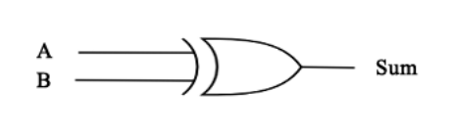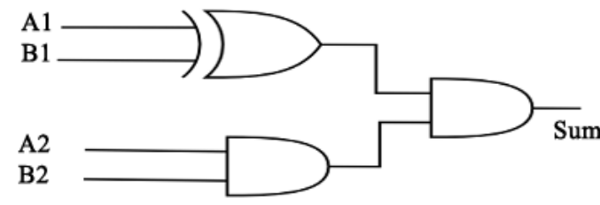
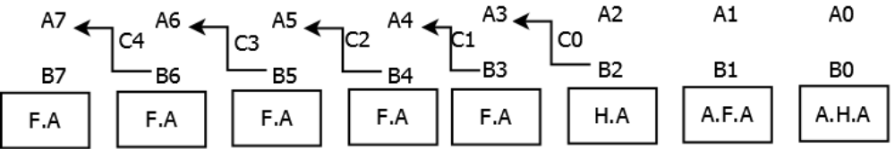
Figure 4.1 DESIGN OF MODIFIED ERROR TOLERANT ADDER

DESIGN OF MODIFIED ERROR TOLERANT ADDER
The Fast Fourier Transform (FFT) is very important function in Digital Signal Processing (DSP) and image processing application. Very large number of additions and multiplications are involved in computational process of FFT. It is therefore a very good platform for embedding novel approaches like Error Tolerance (ET) in the computational.
Based on this, some novel concepts like error tolerance have come into existence. Today, there are some designs such as adders/multipliers which have been proposed but they could not perform well either in terms of power, speed, accuracy or area.
It is true that not all the digital systems can allow the concept of error tolerance. For example, application involving control systems where the accuracy of output signal is very important and hence the concept of error tolerance cannot be applied. However, there are many examples of applications like DSP applications in which human sensing signals such as sight, hearing, touch and smell are being processed, where we can use this concept of error tolerance.
4.1. Error Tolerant Adder
Based on the characteristics of digital VLSI design, some novel concepts and design techniques have been proposed. The concept of Error Tolerance (ET), and the PCMOS technology are two of them. According to the definition, a circuit is error tolerant if: (1) it contains defect that causes internal and may cause external errors and (2) the system that incorporates this circuit produces acceptable results. However, the need for the error tolerant circuit was foretold in the 2003 International Technology Roadmap for Semiconductors (ITRS).
4.1.1. Necessity of Error Tolerant Adder
Requirement for large data sets and fast response has made the adder to be large and fast. Thus, the conventional Ripple Carry Adder (RCA) cannot be used because of its low-speed performance. There are other adders such as Carry Look Ahead (CLA) adder, Carry Select (CSL) adder, Carry Skip (CSK) adder but there is always trade-off between speed and power. The Error Tolerant Adder (ETA) is potential solution to this problem. This research further improves the design model of ETA thereby reducing the chip area and cost of the design.
4.1.2. Adopted Addition Arithmetic
The signal propagating through the different paths with unequal delay will reach at the output at different time. This introduces static-0 and static-1 hazards also called glitches. Thus, in a similar way, carry propagation also decreases the speed of the adder. More so, large power is consumed mainly because of glitches occurring during this process. So, if the carry propagation is avoided, then there can be a large improvement in speed performance and power consumption.
It is true that not all the digital systems can allow the concept of error tolerance. For example, application involving control systems where the accuracy of output signal is very important and hence the concept of error tolerance cannot be applied. However, there are many examples of applications like DSP applications in which human sensing signals such as sight, hearing, touch and smell are being processed, where we can use this concept of error tolerance.

Fig. 4.1 shows the adopted addition arithmetic form where A and B are inputs and S is output. Here, the input operand is divided into two parts. First, the accurate part that includes several higher order bits and second the inaccurate part that have the Least Significant Bits (LSBs). Equal length of both part is not necessary. Consider for an example, A and B are 16-bits input operands. Here for ease of partition both operands are divided in equal part. Addition of accurate part is performed right to left in the conventional way in order to sustain precision as higher bits play an important role in determining accuracy. For inaccurate part, a special addition method is adopted to speed up the process with minimal power consumption. This method eliminates the carry propagation path.
The process is defined in the following three steps: (1) Check every bit position from left to right. If both input bits combination are other than is, conventional 1-bit addition is performed.
If both the input bits found to be ' 1 ' , then all the sum bits to the right of the first occurrence ofinput bits ' I' are set to ' 1' irrespective of the inputs. Consider for an example, A = " 1011001II0011010" and B = "011010010001011". This addition should actually yield "100011 lOOlOIOI 101" (72877) for a normal addition operation but it gives "10001110010011111" (72863) with this method. Thus, the Total Error (TE) can be computed as TE = 172877 - 72870] = 14 and Accuracy (ACC) ACC = (1 - (14/72877)) * 100 % = 99.99 % [8].

CHAPTER 5-PROPOSED METHOD
To design our AMFA circuits, let us first look at a baseline (accurate) full adder in which the outputs (Cout and Sum) can be expressed by (2) and (3) as functions of the inputs A, B, and Ci
 (2)
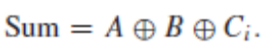 (3)
By looking at the truth table of the baseline full adder, we observe that the output Sum mostly equals the output Cout except for two input combinations: ABCi = “000” and ABCi = “111”. If we approximate the output Sum with the output Cout, we will get two erroneous results out of 8 (25% error) and an error distance of 1. Although it is possible to define Cout = Sum, we decided to approximate Sum instead because an erroneous Cout propagates through the next stages and results in more erroneous results.
By approximating the Sum output as Sum = Cout, we propose two novel MTJ-based non-volatile approximate 1-bit full adders. We also propose a full adder with the unique property of accuracy adjustability, which we will use to design our accuracy-adaptive adder.
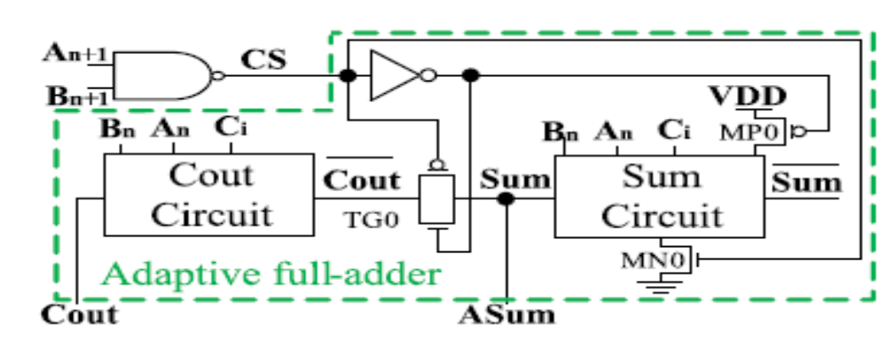
Fig. 5.1 shows the proposed sequential AMFA (S-AMFA)
Circuit that follows (3) and uses three parallel MTJs in order to implement Cout as a majority function. The majority circuit and its complement are shown in Fig.5.1 (labeled MTJ tree), which are connected to the pre-charge sense amplifier (PCSA) circuit. The total resistance of the right and the left branches are given in the following equations:
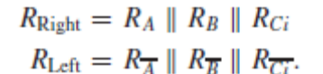

Having two or more inputs of the adder [labeled A, B, and Ci in Fig. 5.1] at logic value, “1” puts MTJs of the left and right branches in the anti-parallel and parallel modes, respectively. As the circuit goes into the evaluation phase (i.e., Clk goes to logic value “1”), the lower resistance of the right branch discharges the ASum node faster than the Cout node. When the Cout voltage reaches the threshold voltage of the MP1 transistor, it turns on the MP1 transistor and connects Cout to VDD, and the ASum net gets discharged to produce the logic value “0.” In the case of having fewer than two inputs with the logic value “0,” the left MTJ branch shows a lower resistance and works faster to make ASum = “1” and Cout = “0.” Table I shows how the S-AMFA circuit works based on the resistance of the left and right branches.
The MTJ networks can be implemented by either three serial or parallel MTJs. In the serial implementation, the total resistance of the MTJ network ranges between 3RAP
and 3RP, which is 9× higher than the total resistance of the parallel implementation (with the total resistance of RP/3 to RAP/3). As previously mentioned, a PCSA circuit compares the total resistance of the two branches and discharges the associated node with the lower resistance branch. Because the MTJ network with the higher resistance discharges slower, the sensing delay increases such that the proposed S-AMFA works faster than the MFA proposed in.
5.1 Proposed Simplified Sequential AMFA
Utilizing two complementary reconfigurable MTJ trees increases read stability and reduces sensing delay due to a higher resistance difference between the left and right branches. As energy is mostly consumed during the reconfiguration of MTJ cells, the proposed S-AMFA would consume a relatively high switching power [18]. To address this issue, we propose a new design called simplified sequential AMFA (SS-AMFA), which uses a fixed MTJ tree along with a reconfigurable MTJ tree. In SS-AMFA, we remove one of the reconfigurable MTJ branches to decrease the dynamic power consumption of the S-AMFA. This comes at the cost of a slight increase in delay and a slight loss in read stability. To apply this idea, let us take a closer look at the functionality of the S-AMFA circuit. When the output of the proposed S-AMFA [Fig. 5(a)] transitions to “1,” the equivalent resistance of the left branch is RAP _ RAP _ RP or higher; at the same time, the equivalent resistance of the right branch is RAP|| RP|| RP or lower. Therefore, we propose to replace the MTJ tree.
When at least two inputs of the SS-AMFA are “0,” the equivalent resistance of the left branch is RP||RP ||RP or RAP || RP ||RP, which is lower than that of the fixed branch (RP/2). The node Cout is discharged faster than the node ASum and takes the “0” logic value. In contrast, when at least two inputs are “1,” the equivalent resistance of the left branch is RAP _ RAP _ RAP or RAP _ RAP _ RAP, which is higher than the resistance of the fixed branch (RP/2).
5.2 Proposed Accuracy-Adaptive AMFA
Fig. 5.1 shows our design to extend the S-AMFA and SS-AMFA to work in either “accurate” or “approximate” mode based on a control signal (CS). This accuracy-adaptive magnetic adder [called adaptive AMFA (A-AMFA)] works in approximate mode if the most significant input bits are “1,” meaning that lower order bits do not carry many important data. A-AMFA deactivates the control signal whenever both most significant bits (MSBs) are “1.” When any MSBs are “0,” the intermediate bits become important, and the adaptive full-adder functions accurately for the intermediate bits as well.
In A-AMFA, shown in Fig. 4, when all MSBs are “1,” CS gets a low state, and accordingly, transistors MP0 and MN0 will turn off power to the Sum circuit. In addition, the outputs of the Sum circuit get a high impedance state, and Cout goes through TG0 to ASum as an approximate output.
In the cases that at least one MSB is “0,” CS gets a high state. In such cases, TG0 turns off, and MP0 and MN0 power ON the Sum circuit. Therefore, ASum generates accurate outputs, and the adaptive circuit functions in accurate mode. This lets us benefit from both the power efficiency of the SS-AMFA and the performance advantage of the S-AMFA as each of these circuits can be the main adder of the circuit
The dividing method is based on the accuracy, speed and power. For more accuracy, there are a smaller number of bits in the inaccurate part and vice-versa. With the method used in we can verify the accuracy performance of the adder and the partition is then adjusted to meet the requirements. Thus, having less bits in the accurate part can greatly reduce the power consumption. Considering the mentioned partition method but for the ease of division procedure, 16-bits were divided equally in accurate part and inaccurate part in the present work.
5.2.1. Design of the Accurate Part
In our proposed 16-bit modified ETA, inaccurate part consist of 8-bits and accurate part contains remaining 8-bits. Thus, the overall delay can be determined by inaccurate part and hence the adder required for accurate part need not to be faster. The most power saving Ripple Carry Adder (RCA) is chosen for the accurate part.
In A-AMFA, shown in Fig. 4, when all MSBs are “1,” CS gets a low state, and accordingly, transistors MP0 and MN0 will turn off power to the Sum circuit. In addition, the outputs of the Sum circuit get a high impedance state, and Cout goes through TG0 to ASum as an approximate output.

5.2.2. Design of the Inaccurate Part
This is the most critical portion of design since it determines the speed, accuracy and power consumption. It consists of two parts, namely Carry Free Addition Block (CFAB) and Control Block (CB). The schematic of modified OR block is shown in Fig.5.2. In proposed modified OR block-1 two more transistor are used whose input depends on CTL signal, where CTL signal is a control signal coming out from Control Block (CB). When CTL = 0, Ml is on and M2 is off leaving the OR block circuit to operate in normal OR operation mode.

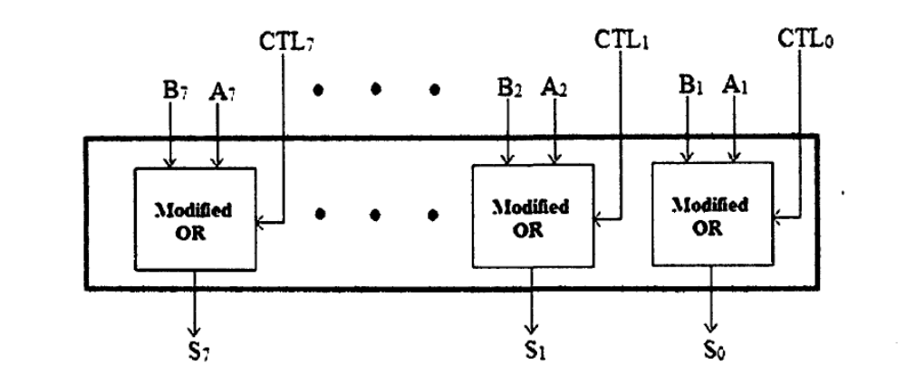
Figure 5.2 Proposed Simplified Sequential AMFA

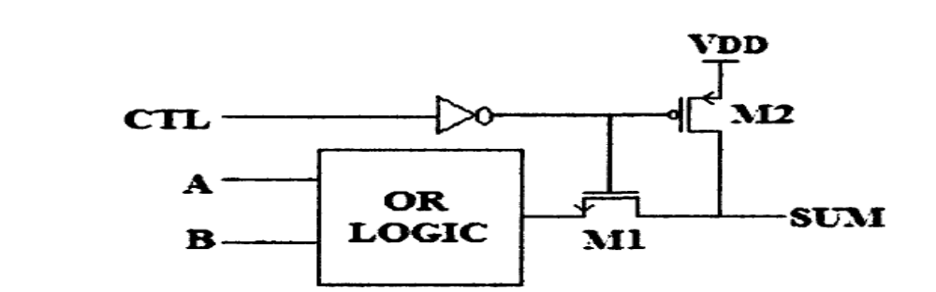

Figure 5.3 Modified OR block-2

When CTL=1, Ml is OFF and M2 is ON, hence the output sets to ' 1 ' by connecting i.e. To solve the problem of passing strong logic ' 1' we have proposed another modified OR block-2 by replacing NMOS with PMOS and rearranging the connection of transistors as shown in Fig. 5.3.
CHAPTER- 6-VLSI Design
6.1 Introduction
The electronics industry has achieved a phenomenal growth over the last two decades, mainly due to the rapid advances in integration technologies, large-scale systems design - in short, due to the advent of VLSI. The number of applications of integrated circuits in high-performance computing, telecommunications, and consumer electronics has been rising steadily, and at a very fast pace. Typically, the required computational power (or, in other words, the intelligence) of these applications is the driving force for the fast development of this field. Gives an overview of the prominent trends in information technologies over the next few decades. The current leading-edge technologies (such as low bit-rate video and cellular communications) already provide the end-users a certain amount of processing power and portability.
VLSI has been around for a long time, there is nothing new about it, but as a side effect of advances in the world of computers, there has been a dramatic proliferation of tools that can be used to design VLSI circuits. Alongside, obeying Moore's law, the capability of an IC has increased exponentially over the years, in terms of computation power, utilization of available area, yield. The combined effect of these two advances is that people can now put diverse functionality into the IC's, opening up new frontiers. Examples are embedded systems, where intelligent devices are put inside everyday objects, and ubiquitous computing where small computing devices proliferate to such an extent that even the shoes you wear may actually do something useful like monitoring your heartbeats.
Verilog was developed at a time when designers were looking for tools to combine different levels of simulation. In the early 1980s, there were switch-level simulators, gate-level simulators, functional simulators (often written ad-hoc in software) and no simple means to combine them. Further, the more-widespread, traditional programming languages themselves were/are essentially sequential and thus "semantically challenged" when modeling the concurrency of digital circuitry.
In 1989, Gateway Design Automation (and rights to Verilog) was purchased by Cadence who put Verilog in the public domain in the following year. This move did much to promote the use of Verilog since other companies were able to develop alternatives tools to those of Cadence which, in turn, allowed users to adopt Verilog without dependency on a single (primarily workstation-tool) supplier. In 1992, work began to create an IEEE standard (IEEE-1364) and in December 1995 the final draft was approved.
While Verilog emerged from developments within private companies, its main rival came from the American Department of Defense (DoD). In 1981, the DoD sponsored a workshop on hardware description languages as part of its Very High Speed Integrated Circuits (VHSIC) program, and the outcome formed a specification for the VHSIC hardware description language (VHDL) in 1983. There is, of course, the question as to which language is better. And this, of course, is a hard question to answer without causing excitement and rebuttals from the marketing departments of the less preferred language. However, the following points featured in a recent debate in the VHDL and Verilog news groups.
The main factor is the language syntax - since Verilog is based on C and VHDL is based on ADA.Verilog is easier to learn since C is a far simpler language. It also produces more compact code: easier both to write and to read. Furthermore, the large number of engineers who already know C (compared to those who know ADA) makes learning and training easier. VHDL is very strongly typed, and allows programmer to define their own types although, in practice, the main types used are either the basic types of the language itself, or those defined by the IEEE. The benefit is that type checking is performed by the compiler which can reduce errors; the disadvantage is that changing types must be done explicitly.
6.2 ASICS
Progress in the fabrication of IC's has enabled us to create fast and powerful circuits in smaller and smaller devices. This also means that we can pack a lot more of functionality into the same area. The biggest application of this ability is found in the design of ASIC's. These are IC's that are created for specific purposes - each device is created to do a particular job, and do it well. The most common application area for this is DSP - signal filters, image compression, etc. To go to extremes, consider the fact that the digital wristwatch normally consists of a single IC doing all the time-keeping jobs as well as extra features like games, calendar, etc.
6.3 FPGA
Fully fabricated FPGA chips containing thousands of logic gates or even more, with programmable interconnects, are available to users for their custom hardware programming to realize desired functionality. This design style provides a means for fast prototyping and also for cost-effective chip design, especially for low-volume applications. A typical field programmable gate array (FPGA) chip consists of I/O buffers, an array of configurable logic blocks (CLBs), and programmable interconnect structures. The programming of the interconnects is implemented by programming of RAM cells whose output terminals.
A simple CLB (model XC2000 from XILINX) It consists of four signal input terminals (A, B, C, D), a clock signal terminal, user-programmable multiplexers, an SR-latch, and a look-up table (LUT). The LUT is a digital memory that stores the truth table of the Boolean function. Thus, it can generate any function of up to four variables or any two functions of three variables.
CLB is config such that many different logic functions can be realized by programming its array. More sophisticated CLBs have also been introduced to map complex functions. The typical design flow of an FPGA chip starts with the behavioral description of its functionality, using a hardware description language such as VHDL. The synthesized architecture is then technology-mapped (or partitioned) into circuits or logic cells. At this stage, the chip design is completely described in terms of available logic cells. Next, the placement and routing step assigns individual logic cells to FPGA sites (CLBs) and determines the routing patterns among the cells in accordance with the net list. After routing is completed, the on-chip.
The largest advantage of FPGA-based design is the very short turn-around time, i.e., the time required from the start of the design process until a functional chip is available. Since no physical manufacturing step is necessary for customizing the FPGA chip, a functional sample can be obtained almost as soon as the design is mapped into a specific technology.
6.3.1 Gate Array Design
In view of the fast-prototyping capability, the gate array (GA) comes after the FPGA. While the design implementation of the FPGA chip is done with user programming, that of the gate array is done with metal mask design and processing. Gate array implementation requires a two-step manufacturing process: The first phase, which is based on generic (standard) masks, results in an array of uncommitted transistors on each GA chip.
6.3.2 Standard-Cells Based Design
The standard-cells based design is one of the most prevalent full custom design styles which require development of a full custom mask set. The standard cell is also called the police. In this design style, all of the commonly used logic cells are developed, characterized, and stored in a standard cell library. A typical library may contain a few hundred cells including inverters, NAND gates, NOR gates, complex AOI, OAI gates, D-latches, and flip-flops. Each gate type can have multiple implementations to provide adequate driving capability for different fan outs. For instance, the inverter gate can have standard size transistors, double size transistors, and quadruple size transistors so that the chip designer can choose the proper size to achieve high circuit speed and layout density. The characterization of each cell is done for several different categories. It consists of
- delay time vs. load capacitance
- circuit simulation model
- timing simulation model
- fault simulation model
- cell data for place-and-route
- mask data
To enable automated placement of the cells and routing of inter-cell connections, each cell layout is designed with a fixed height, so that a number of cells can be abutted side-by-side to form rows. The power and ground rails typically run parallel to the upper and lower boundaries of the cell, thus, neighboring cells share a common power and ground bus. The input and output pins are located on the upper and lower boundaries of the cell. The layout of a typical standard cell. Notice that the nMOS transistors are located closer to the ground rail while the pMOS transistors are placed closer to the power rail.
6.4 VERILOG
Verilog HDL is a Hardware Description Language (HDL). A Hardware Description Language is a language used to describe a digital system, for example, a computer or a component of a computer. One may describe a digital system at several levels. For example, an HDL might describe the layout of the wires, resistors and transistors on an Integrated Circuit (IC) chip, i.e., the switch level or, it might describe the logical gates and flip flops in a digital system, i.e., the gate level. An even higher level describes the registers and the transfers of vectors of information between registers. This is called the Register Transfer Level (RTL). Verilog supports all of these levels. However, this handout focuses on only the portions of Verilog which support the RTL level.
Verilog is one of the two major Hardware Description Languages (HDL) used by hardware designers in industry and academia. VHDL is the other one. The industry is currently split on which is better. Many feel that Verilog is easier to learn and use than VHDL. As one hardware designer puts it, "I hope the competition uses VHDL." VHDL was made an IEEE Standard in 1987, while Verilog is still in the IEEE standardization process.

6.4.1 History
Verilog was introduced in 1985 by Gateway Design System Corporation, now a part of Cadence Design Systems, Inc.'s Systems Division. Until May, 1990, with the formation of Open Verilog International (OVI), Verilog HDL was a proprietary language of Cadence. Cadence was motivated to open the language to the Public Domain with the expectation that the market for Verilog HDL-related software products would grow more rapidly with broader acceptance of the language. Cadence realized that Verilog HDL users wanted other software and service companies to embrace the language and develop Verilog-supported design tools.
To enable automated placement of the cells and routing of inter-cell connections, each cell layout is designed with a fixed height, so that a number of cells can be abutted side-by-side to form rows. The power and ground rails typically run parallel to the upper and lower boundaries of the cell, thus, neighboring cells share a common power and ground bus. The input and output pins are located on the upper and lower boundaries of the cell. The layout of a typical standard cell. Notice that the nMOS transistors are located closer to the ground rail while the pMOS transistors are placed closer to the power rail.
To enable automated placement of the cells and routing of inter-cell connections, each cell layout is designed with a fixed height, so that a number of cells can be abutted side-by-side to form rows. The power and ground rails typically run parallel to the upper and lower boundaries of the cell, thus, neighboring cells share a common power and ground bus. The input and output pins are located on the upper and lower boundaries of the cell. The layout of a typical standard cell. Notice that the nMOS transistors are located closer to the ground rail while the pMOS transistors are placed closer to the power rail.
Verilog HDL allows a hardware designer to describe designs at a high level of abstraction such as at the architectural or behavioral level as well as the lower implementation levels (i. e. , gate and switch levels) leading to Very Large Scale Integration (VLSI) Integrated Circuits (IC) layouts and chip fabrication. A primary use of HDLs is the simulation of designs before the designer must commit to fabrication. This handout does not cover all of Verilog HDL but focuses on the use of Verilog HDL at the architectural or behavioral levels. The handout emphasizes design at the Register Transfer Level (RTL).
6.4.2 Verilog Design Issues
There are now two industry standard hardware description languages, VHDL and Verilog. The complexity of ASIC and FPGA designs has meant an increase in the number of specialist design consultants with specific tools and with their own libraries of macro and mega cells written in either VHDL or Verilog. As a result, it is important that designers know both VHDL and Verilog and that EDA tools vendors provide tools that provide an environment allowing both languages to be used in unison. For example, a designer might have a model of a PCI bus interface written in VHDL, but wants to use it in a design with macros written in Verilog.

6.4.3 Importance of HDLs
HDLs have many advantages compared to traditional schematic-based design.
- Designs can be described at a very abstract level by use of HDLs. Designers can write their RTL description without choosing a specific fabrication technology. Logic synthesis tools can automatically convert the design to any fabrication technology. If a new technology emerges, designers do not need to redesign their circuit. They simply input the RTL description to the logic synthesis tool and create a new gate-level net list, using the new fabrication technology. The logic synthesis tool will optimize the circuit in area and timing for the new technology.
- By describing designs in HDLs, functional verification of the design can be done early in the design cycle. Since designers work at the RTL level, they can optimize and modify the RTL description until it meets the desired functionality. Most design bugs are eliminated at this point. This cuts down design cycle time significantly because the probability of hitting a functional bug at a later time in the gate-level net list or physical layout is minimized.
- Designing with HDLs is analogous to computer programming. A textual description with comments is an easier way to develop and debug circuits. This also provides a concise representation of the design, compared to gate-level schematics. Gate-level schematics are almost incomprehensible for very complex designs.
HDL-based design is here to stay. With rapidly increasing complexities of digital circuits and increasingly sophisticated EDA tools, HDLs are now the dominant method for large digital designs. No digital circuit designer can afford to ignore HDL-based design.

6.4.4 Popularity Of Verilog HDL

Verilog HDL has evolved as a standard hardware description language. Verilog HDL offers many useful features
- Verilog HDL is a general-purpose hardware description language that is easy to learn and easy to use. It is similar in syntax to the C programming language. Designers with C programming experience will find it easy to learn Verilog HDL.
- Verilog HDL allows different levels of abstraction to be mixed in the same model. Thus, a designer can define a hardware model in terms of switches, gates, RTL, or behavioral code. Also, a designer needs to learn only one language for stimulus and hierarchical design.
- Most popular logic synthesis tools support Verilog HDL. This makes it the language of choice for designers.
- All fabrication vendors provide Verilog HDL libraries for postlogic synthesis simulation. Thus, designing a chip in Verilog HDL allows the widest choice of vendors.
- The Programming Language Interface (PLI) is a powerful feature that allows the user to write custom C code to interact with the internal data structures of Verilog. Designers can customize a Verilog HDL simulator to their needs with the PLI.

6.4.5 Trends In HDLs
- The speed and complexity of digital circuits have increased rapidly. Designers have responded by designing at higher levels of abstraction. Designers have to think only in terms of functionality. EDA tools take care of the implementation details. With designer assistance, EDA tools have become sophisticated enough to achieve a close-to-optimum implementation.
- The most popular trend currently is to design in HDL at an RTL level, because logic synthesis tools can create gate-level netlists from RTL level design. Behavioral synthesis allowed engineers to design directly in terms of algorithms and the behavior of the circuit, and then use EDA tools to do the translation and optimization in each phase of the design. However, behavioral synthesis did not gain widespread acceptance. Today, RTL design continues to be very popular. Verilog HDL is also being constantly enhanced to meet the needs of new verification methodologies.
- Formal verification and assertion checking techniques have emerged. Formal verification applies formal mathematical techniques to verify the correctness of Verilog HDL descriptions and to establish equivalency between RTL and gate-level netlists.
- New verification languages have also gained rapid acceptance. These languages combine the parallelism and hardware constructs from HDLs with the object-oriented nature of C++. These languages also provide support for automatic stimulus creation, checking, and coverage. However, these languages do not replace Verilog HDL.
- For very high-speed and timing-critical circuits like microprocessors, the gate-level netlist provided by logic synthesis tools is not optimal. In such cases, designers often mix gate-level description directly into the RTL description to achieve optimum results. This practice is opposite to the high-level design paradigm, yet it is frequently used for high-speed designs because designers need to squeeze the last bit of timing out of circuits, and EDA tools sometimes prove to be insufficient to achieve the desired results.
- New verification languages have also gained rapid acceptance. These languages combine the parallelism and hardware constructs from HDLs with the object oriented nature of C++. These languages also provide support for automatic stimulus creation, checking, and coverage. However, these languages do not replace Verilog HDL. They simply boost the productivity of the verification process. Verilog HDL is still needed to describe the design.
- Formal verification and assertion checking techniques have emerged. Formal verification applies formal mathematical techniques to verify the correctness of Verilog HDL descriptions and to establish equivalency between RTL and gate-level netlists.
- The most popular trend currently is to design in HDL at an RTL level, because logic synthesis tools can create gate-level netlists from RTL level design. Behavioral synthesis allowed engineers to design directly in terms of algorithms and the behavior of the circuit, and then use EDA tools to do the translation and optimization in each phase of the design. However, behavioral synthesis did not gain widespread acceptance. Today, RTL design continues to be very popular. Verilog HDL is also being constantly enhanced to meet the needs of new verification methodologies.
- For very high-speed and timing-critical circuits like microprocessors, the gate-level netlist provided by logic synthesis tools is not optimal. In such cases, designers often mix gate-level description directly into the RTL description to achieve optimum results. This practice is opposite to the high-level design paradigm, yet it is frequently used for high-speed designs because designers need to squeeze the last bit of timing out of circuits, and EDA tools sometimes prove to be insufficient to achieve the desired results.

6.4.6 Typical Design Flow
A typical design flow for designing VLSI-IC circuits is shown in the below Fig 4.1. Unshaved blocks show the level of design representation; shaded blocks show processes in the design flow.
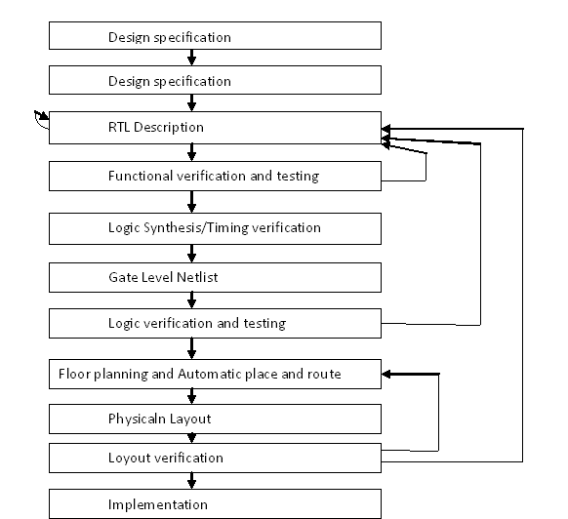
Fig 6.1 Typical Design Flow

The design flow shown in Fig 6.1 is typically used by designers who use HDLs. In any design, specifications are written first. Specifications describe abstractly the functionality, interface, and overall architecture of the digital circuit to be designed. At this point, the architects do not need to think about how they will implement this circuit. A behavioral description is then created to analyze the design in terms of functionality, performance, and compliance to standards, and other high-level issues. Behavioral descriptions are often written with HDLs. The behavioral description is manually converted to an RTL description in an HDL. The designer has to describe the data flow that will implement the desired digital circuit. From this point onward, the design process is done with the assistance of EDA tools.
Designing at the RTL level has shrunk the design cycle times from years to a few months. It is also possible to do many design iterations in a short period of time. Behavioral synthesis tools have begun to emerge recently. These tools can create RTL descriptions from a behavioral or algorithmic description of the circuit. As these tools mature, digital circuit design will become similar to high-level computer programming.
It is important to note that, although EDA tools are available to automate the processes and cut design cycle times, the designer is still the person who controls how the tool will perform. EDA tools are also susceptible to the "GIGO : Garbage In Garbage Out" phenomenon. If used improperly, EDA tools will lead to inefficient designs. Thus, the designer still needs to understand the nuances of design methodologies, using EDA tools to obtain an optimized design.
6.5 Field Programmable Gate Arrays
Before the advent of programmable logic, custom logic circuits were built at the board level using standard components, or at the gate level in expensive application-specific (custom) integrated circuits. The FPGA is an integrated circuit that contains many (64 to over 10,000) identical logic cells that can be viewed as standard components. Each logic cell can independently take on any one of a limited set of personalities. The individual cells are interconnected by a matrix of wires and programmable switches.
Similar to microprocessors, FPGAs optionally load or boot themselves automatically from an external nonvolatile memory device. Alternatively, similar to microprocessor peripherals, Spartan-3 generation FPGAs can be downloaded or programmed by an external “smart agent”, such as a microprocessor, DSP processor, microcontroller, PC, or board tester.
Designing at the RTL level has shrunk the design cycle times from years to a few months. It is also possible to do many design iterations in a short period of time. Behavioral synthesis tools have begun to emerge recently. These tools can create RTL descriptions from a behavioral or algorithmic description of the circuit. As these tools mature, digital circuit design will become similar to high-level computer programming.
The FPGA is an integrated circuit that contains many (64 to over 10,000) identical logic cells that can be viewed as standard components. Each logic cell can independently take on any one of a limited set of personalities. The individual cells are interconnected by a matrix of wires and programmable switches.

CHAPTER 7-SOFTWARE REQUIREMENTS
7.1 XILINX
It requires Xilinx ISE 13.1 version of software where Verilog source code can be used for design implementation.
7.1.1 Introduction to XILINX ISE:
This instrument can be utilized to make, execute, reenact, and integrate Verilog outlines for usage on FPGA chips.
ISE: Integrated Software Environment
- Environment for the improvement and trial of computerized systems configuration focused to FPGA or CPLD
- Integrated gathering of apparatuses available through a GUI
- Based on an intelligent combination motor (XST: Xilinx Synthesis Technology)
XST underpins diverse dialects:
- Verilog
- VHDL
- XST create a net rundown incorporated with requirements
- Supports every one of the means required to finish the plan:
- Translate, guide, place and course
- Bit stream era
For this situation, it is conceivable to utilize Verilog to compose a test seat to confirm the usefulness of the outline utilizing documents on the host PC to characterize jolts, to interface with the client, and to contrast comes about and those normal.
A Verilog show is converted into the "doors and wires" that are mapped onto a programmable rationale gadget, for example, a CPLD or FPGA, and after that it is the real equipment being designed, instead of the Verilog code being "executed" as though on some type of a processor chip.

7.1.2 Implementation:
- Synthesis (XST)
-Produce a netlist file starting from an HDL description
- Translate (NGDBuild)
- Converts all input design netlists and then writes the results into a single merged file, that describes logic and constraints.
- Mapping (MAP)
- Maps the logic on device components.
- Takes a netlist and groups the logical elements into CLBs and IOBs (components of FPGA).
- Place And Route (PAR)
- Place FPGA cells and connects cells.
- Bit stream generation

7.1.3 XILINX Design Process:
Step 1: Design entry
– HDL (Verilog or VHDL, ABEL x CPLD), Schematic Drawings, Bubble Diagram
Step 2: Synthesis
– Translates .v, .vhd, .sch files into a netlist file (.ngc)
Step 3: Implementation
– FPGA: Translate/Map/Place & Route, CPLD: Fitter
Step 4: Configuration/Programming
– Download a BIT file into the FPGA
– Program JEDEC file into CPLD
– Program MCS file into Flash PROM
Simulation can occur after steps 1, 2, 3
The tools used in this thesis are XILINX ISE 13.1 for simulation and Synthesis. The programs are written in Verilog language.
Xilinx Tools is a suite of software tools used for the design of digital circuits implemented using Xilinx Field Programmable Gate Array (FPGA) or Complex Programmable Logic Device (CPLD). The design procedure consists of (a) design entry, (b) synthesis and implementation of the design, (c) functional simulation and (d) testing and verification. Digital designs can be entered in various ways using the above CAD tools.
7.1.4 Creating a New Project
Xilinx Tools can be started by clicking on the Project Navigator Icon on the Windows desktop. This should open up the Project Navigator window on your screen. This window shows (see Figure 1) the last accessed project.
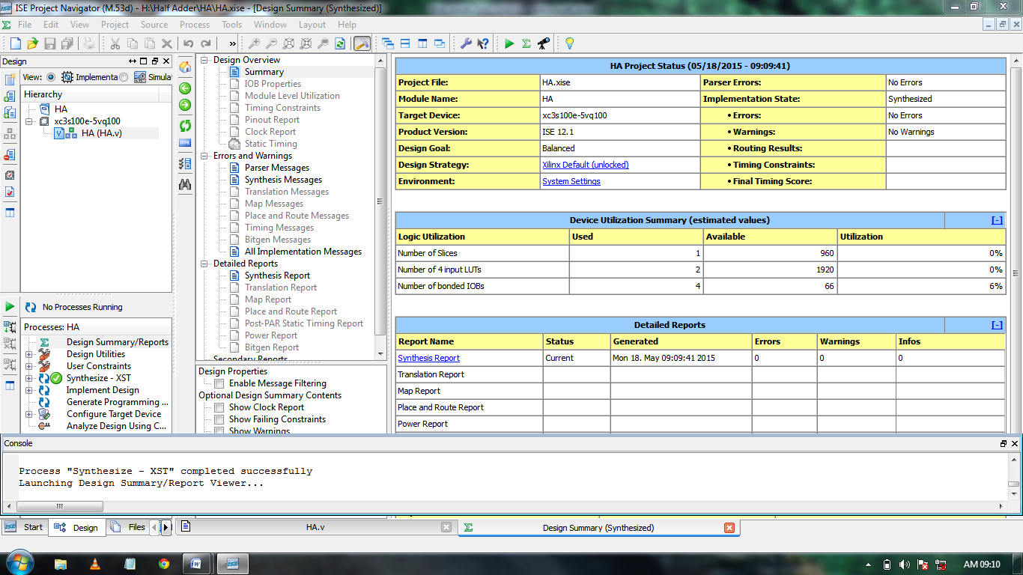
Figure 7.1.4 Creating a new project
7.1.5 Opening a project
Select File->New Project to create a new project. This will bring up a new project window (Figure 2) on the desktop. Fill up the necessary entries as follows:
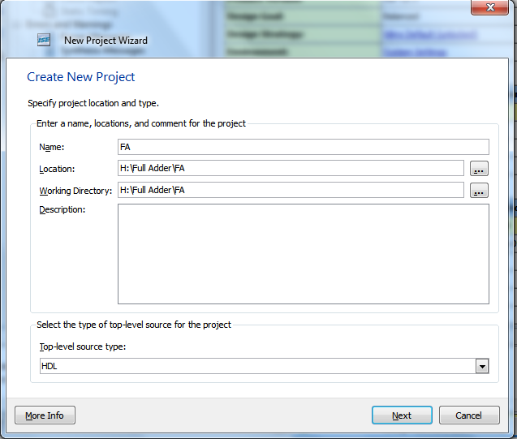
Figure 7.1.5 Opening a project
Project Name: Write the name of your new project

Project Location: The directory where you want to store the new project (Note: DO NOT specify the project location as a folder on Desktop or a folder in the Xilinx\bin directory. Your H: drive is the best place to put it. The project location path is NOT to have any spaces in it eg: H:\Full Adder\F A is NOT to be used).Leave the top level module type as HDL.
Clicking on NEXT should bring up the following window:
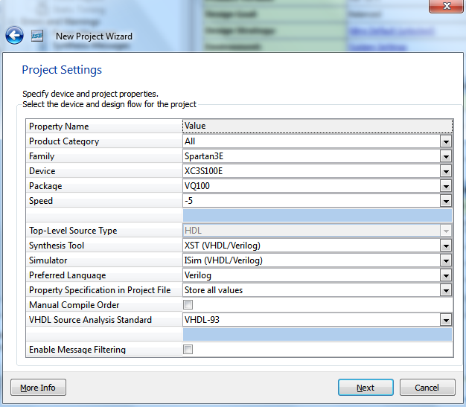
Figure 7.1.5 New project Wizard
For each of the properties given below, click on the ‘value’ area and select from the list of values that appear.
Device Family: Family of the FPGA/CPLD used. In this thesis we will be using the Spartan3E FPGA’s.
Device: The number of the actual device. For this lab you may enter XC3S100E (this can be found on the attached prototyping board)
Package: The type of package with the number of pins. The Spartan FPGA used in this lab is packaged in VQ100 package.
Speed Grade: The Speed grade is “-5”.
Synthesis Tool: XST [VHDL/Verilog]

Simulator: The tool used to simulate and verify the functionality of the design. Modelsim simulator is integrated in the Xilinx ISE. Hence choose “Modelsim-XE Verilog” as the simulator or even Xilinx ISE Simulator can be used.
Then click on NEXT to save the entries.
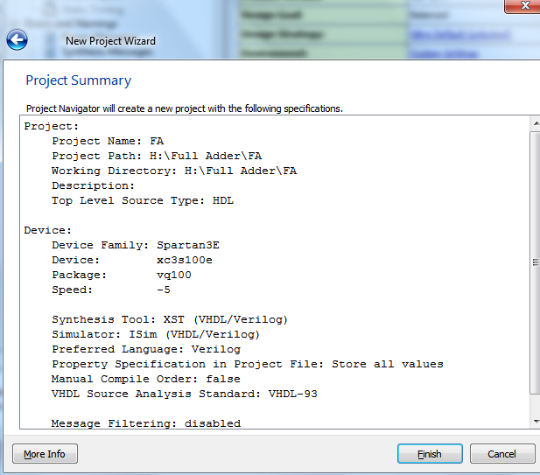
Figure 7.1.5 Project Summery
A project summary window is opened click on finish.
In order to open an existing project in Xilinx Tools, select File->Open Project to show the list of projects on the machine. Choose the project you want and click OK.
Clicking on NEXT on the above window brings up the following window:
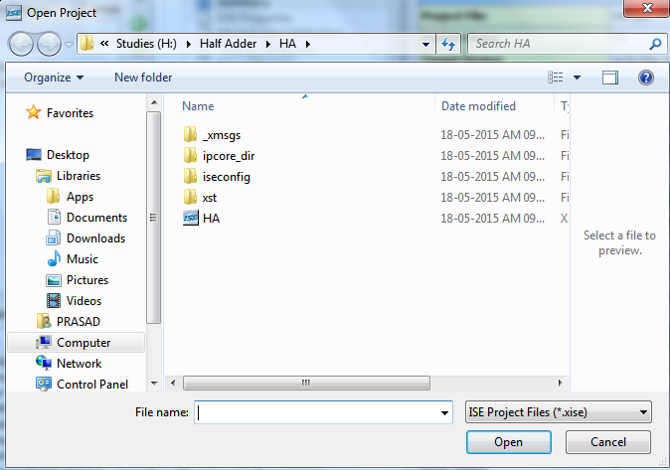
Figure 7.1.5 Open project

If creating a new source file, Click on the NEW SOURCE.
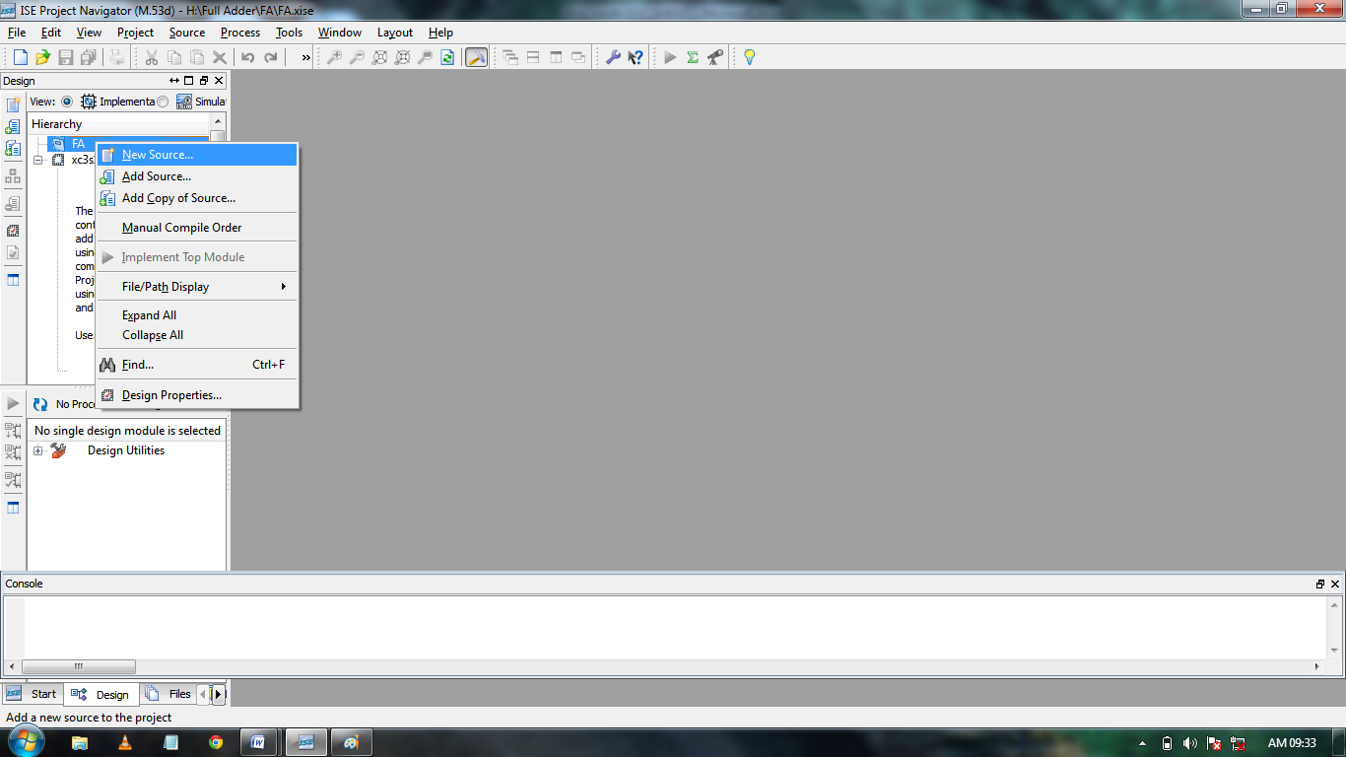
Figure 7.1.5 Click on the NEW SOURCE
A window pop up is opened.
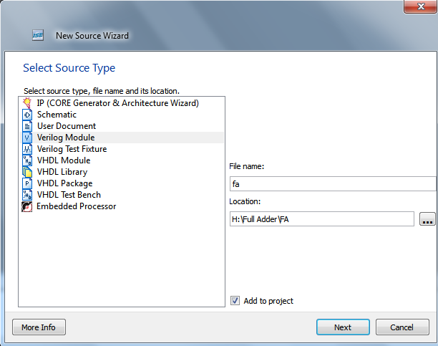
Figure 7.1.5 New Source Wizard
Select Verilog Module and in the “File Name:” Enter the name of the Project. Then click on Next to accept the entries. This pops up the following window.
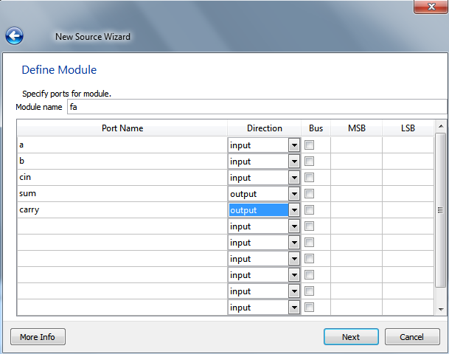
Figure 7.1.5 Define Module

In the Port Name column, enter the names of all input and output pins and specify the Direction accordingly. A Vector/Bus can be defined by entering appropriate bit numbers in the MSB/LSB columns. Then click on Next>to get a window showing all the new source information.
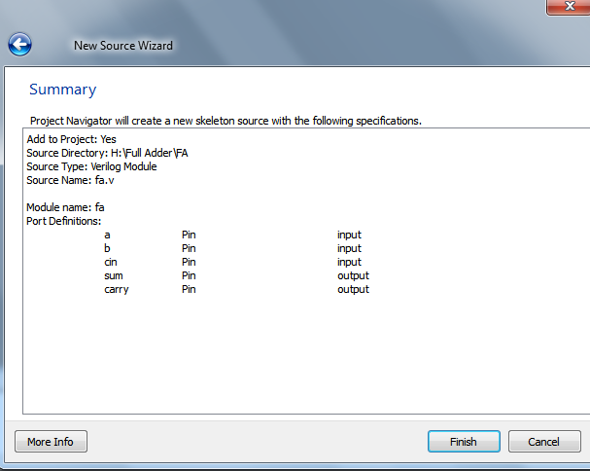
Figure 7.1.5 Summary

click on Finish to continue.
The source file will now be displayed in the Project Navigator window.
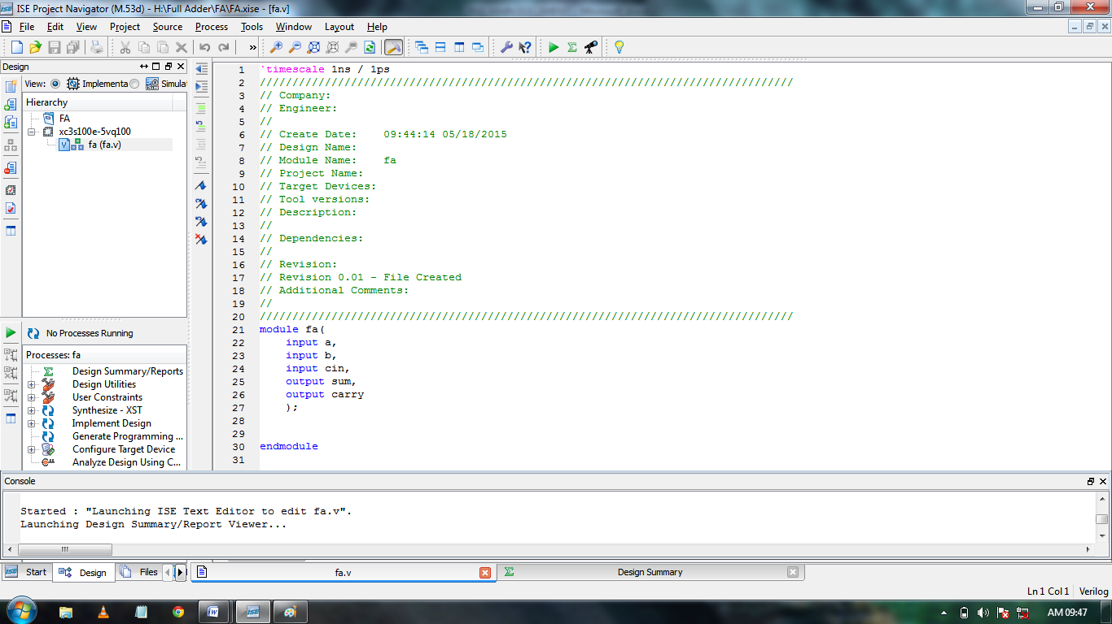
Figure 7.1.5 Project Navigator window

The source file window can be used as a text editor to make any necessary changes to the source file. All the input/output pins will be displayed. Save your Verilog program periodically by selecting the File->Save from the menu. You can also edit Verilog programs in any text editor and add them to the project directory using “Add Copy Source”.
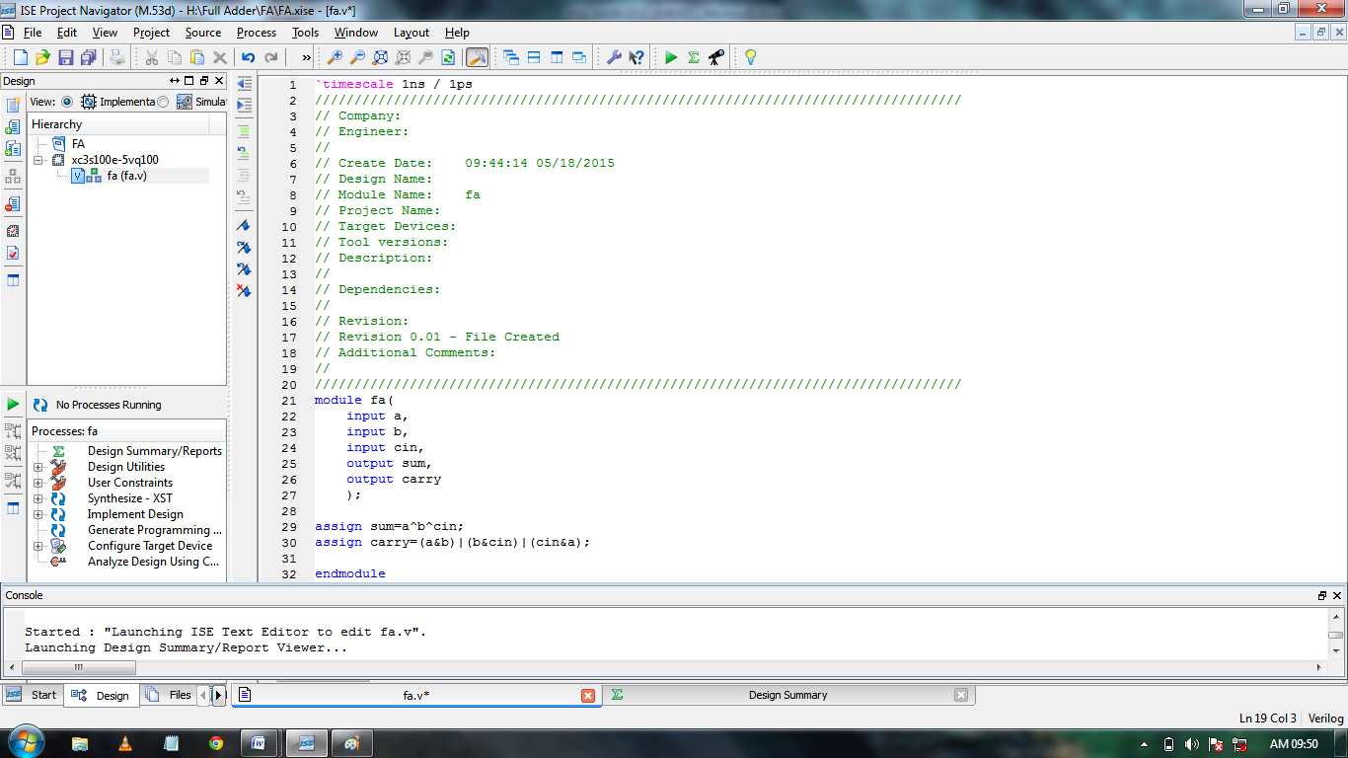
Figure 7.1.5 Project Navigator window

7.1.6 Simulating and Viewing the Output Waveforms:
Click on simulation select the existing file and expand ISim Simulator and click on Behavioral check syntax to check the Errors.
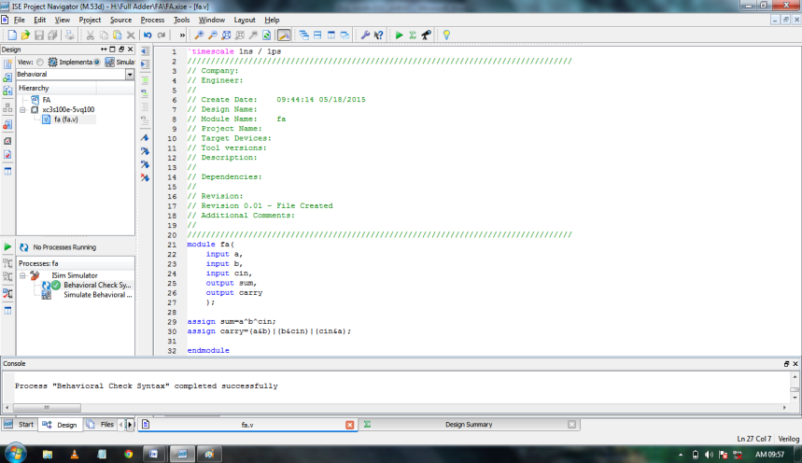
Figure 7.1.6 ISim Simulator

If there are no errors click on simulate behavioral model. A window pop up is opened.
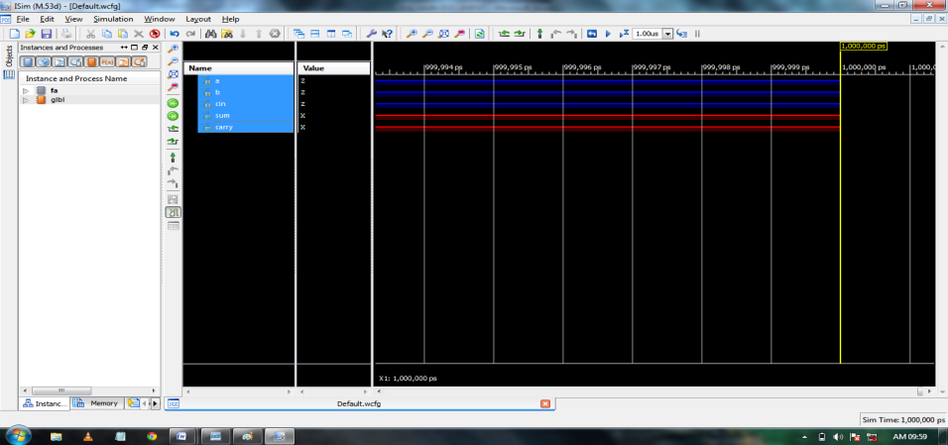
Figure 7.1.6 Simulate behavioral model

Here we can give the inputs. Right click on the selected input click on force constant and enter the input value click on Ok.
Click on Run option in the tool bar to check input and output waveforms.
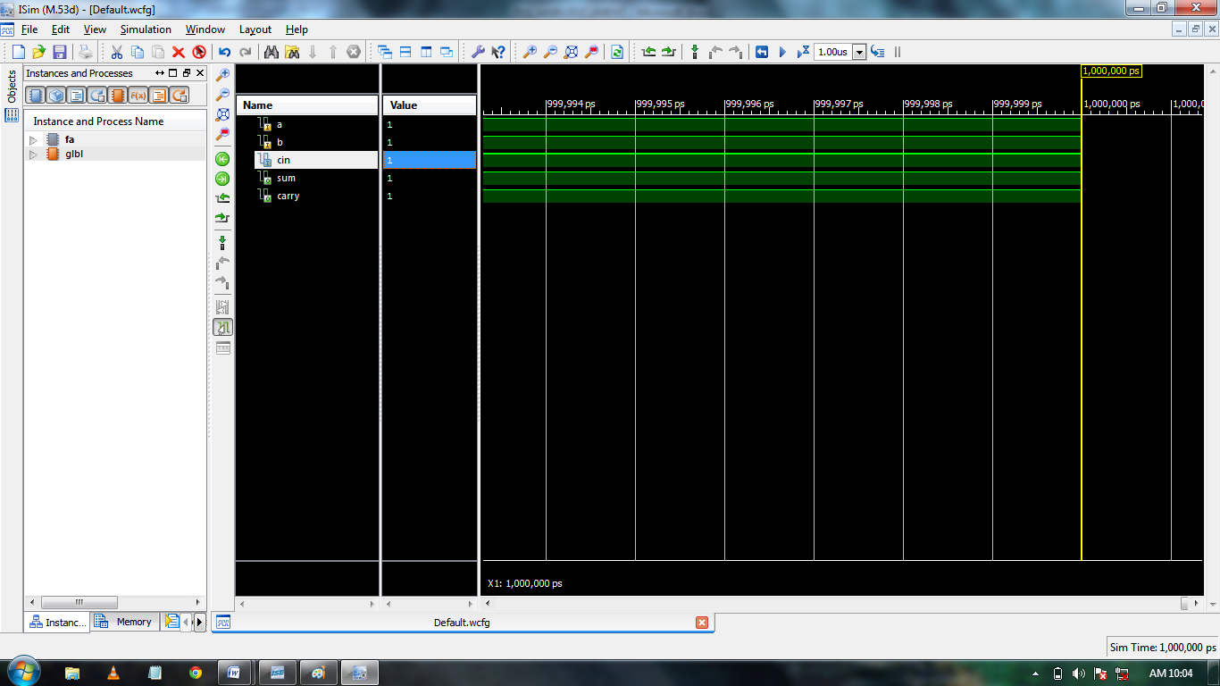
Figure 7.1.6 Check input and output waveforms

7.1.7. Synthesis and Implementation of the Design:
Click on Implementation select the existing file and double click on Synthesize-XST. If there are errors correct it. If there are no errors click on design summary and reports.
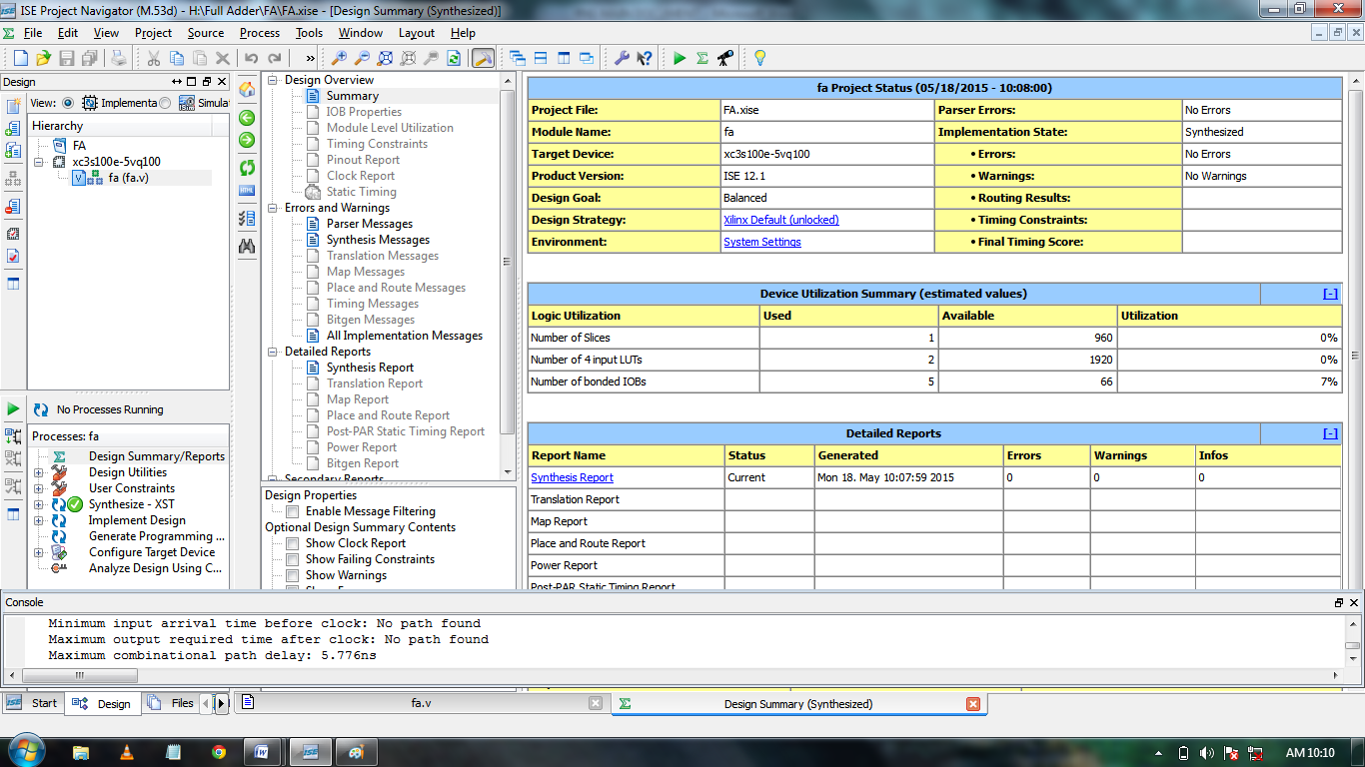
Figure 7.1.7 Synthesis and Implementation of the Design

Open the Synthesis Report in the Detailed Reports to see the Device Utilization Summary and Timing Report of the current project.
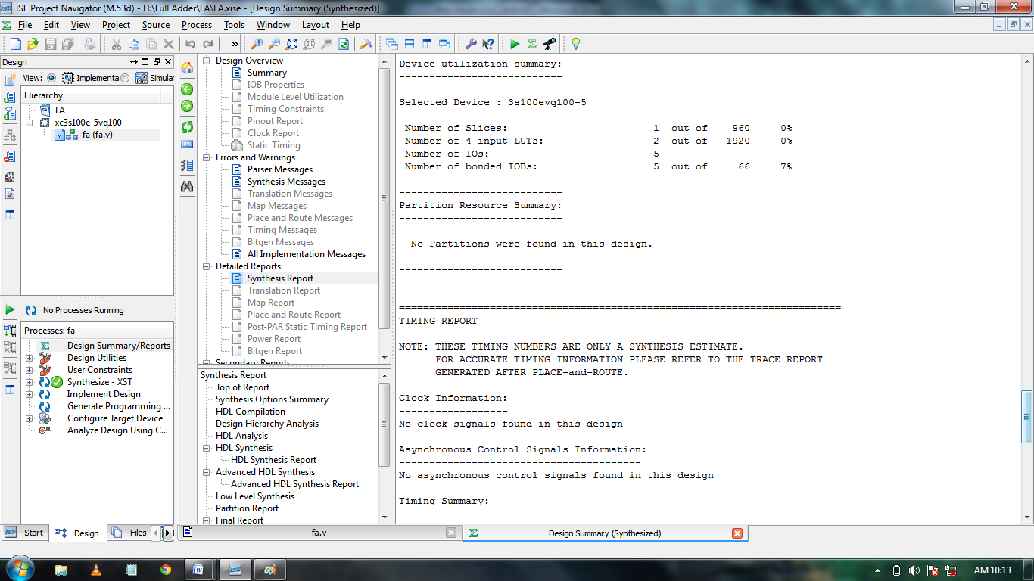
Figure 7.1.7 Device Utilization Summary and Timing Report

7.1.8 View RTL Schematic:
Expand Synthesize-XST and click on view RTL Schematic and click ok.
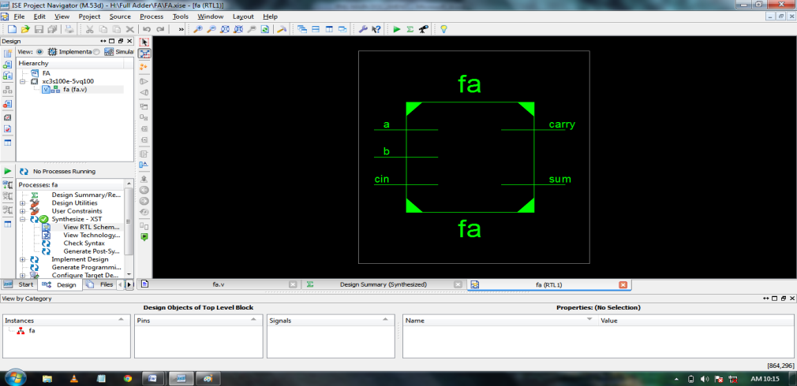
Figure 7.1.8 View RTL Schematic

The window with Top module is opened to view the internal modules click on the top module.
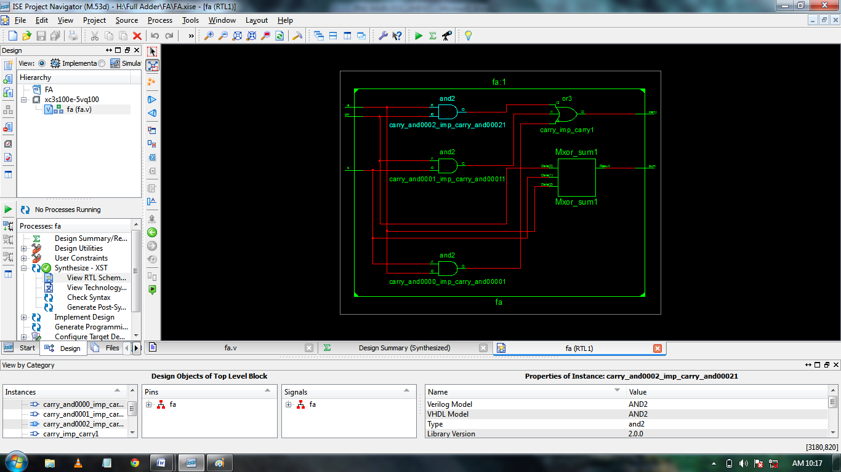
Figure 7.1.8 View RTL Schematic Output

CHAPTER 8-SIMULATION RESULTS
8.1 Results
8.1.1 Simulation Result of Adder:
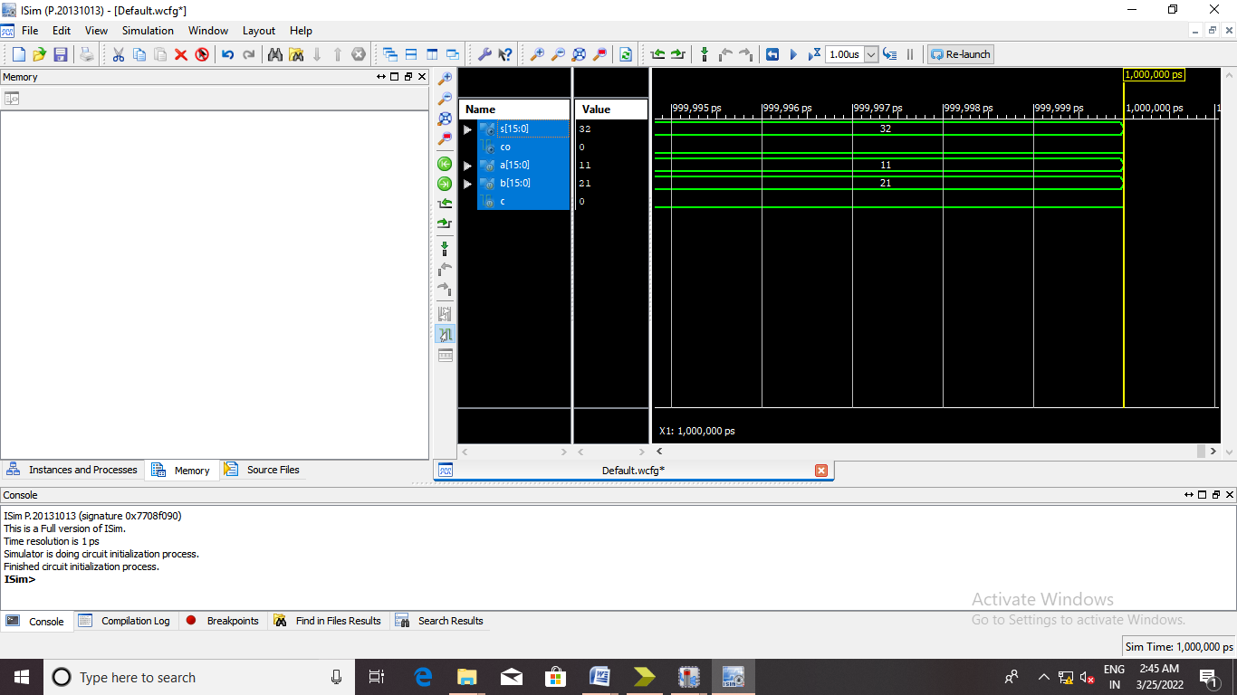
Fig 8.1 Simulation Result of adder
Here we can give the inputs as A=21, B=11, then the final output is 32.

8.1.2 RTL SCHEMATIC OF Adder:
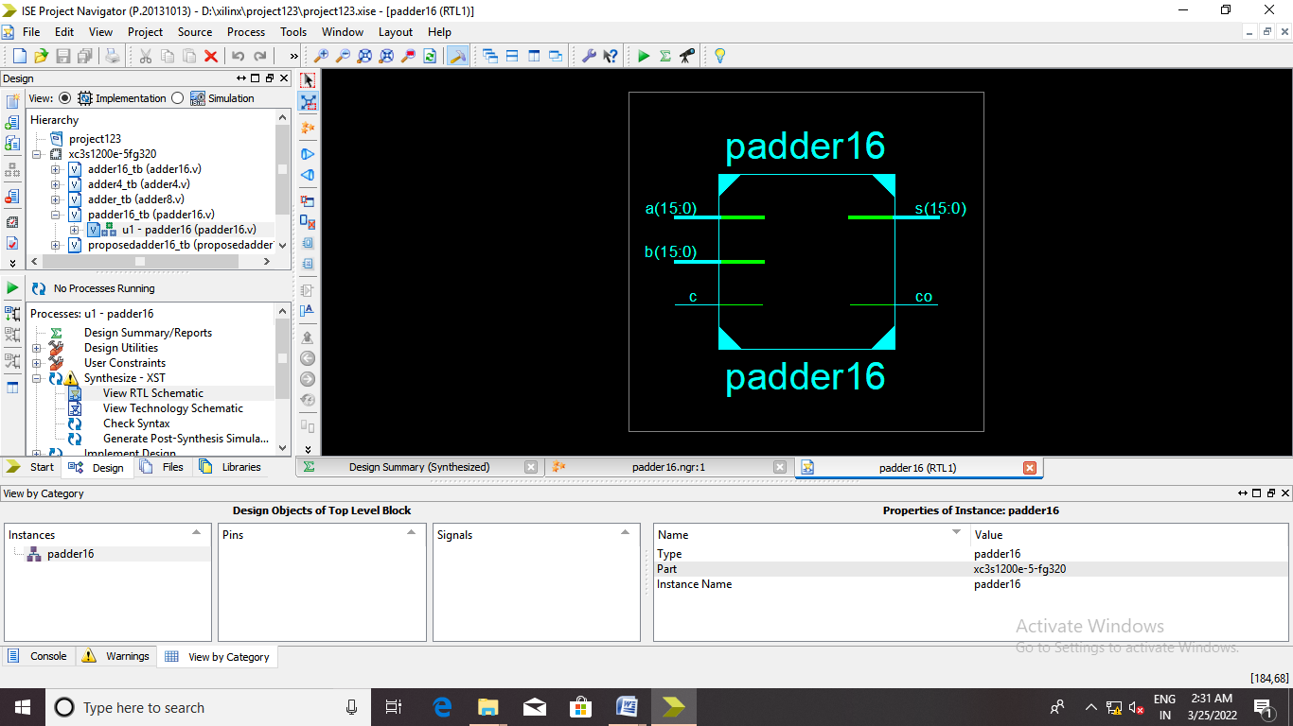
Fig 8.2 RTL Schematic of adder

8.1.3 INTERNAL DIAGRAM OF RTL SCHEMATIC:
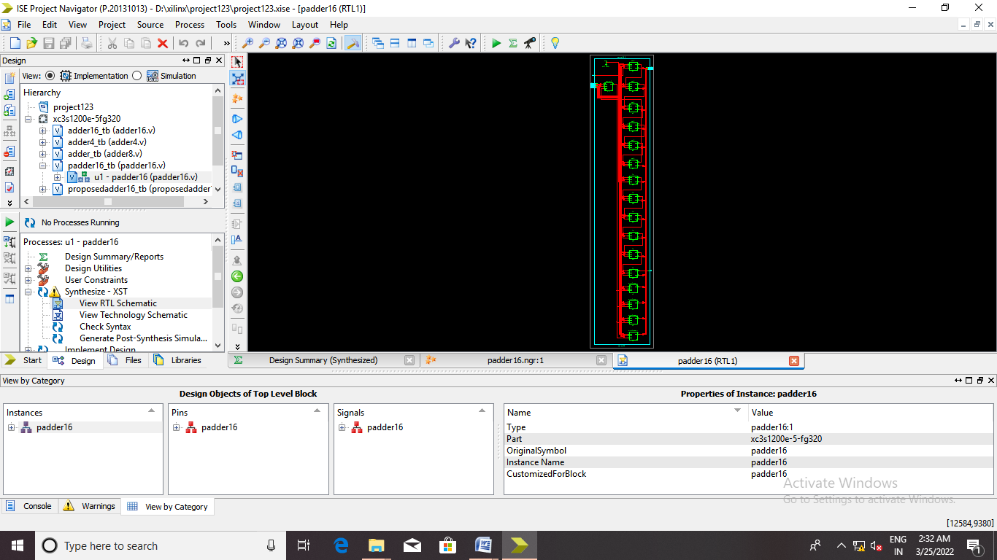
Fig 8.3 Internal diagram of RTL schematic
8.1.4 Estimation of power:
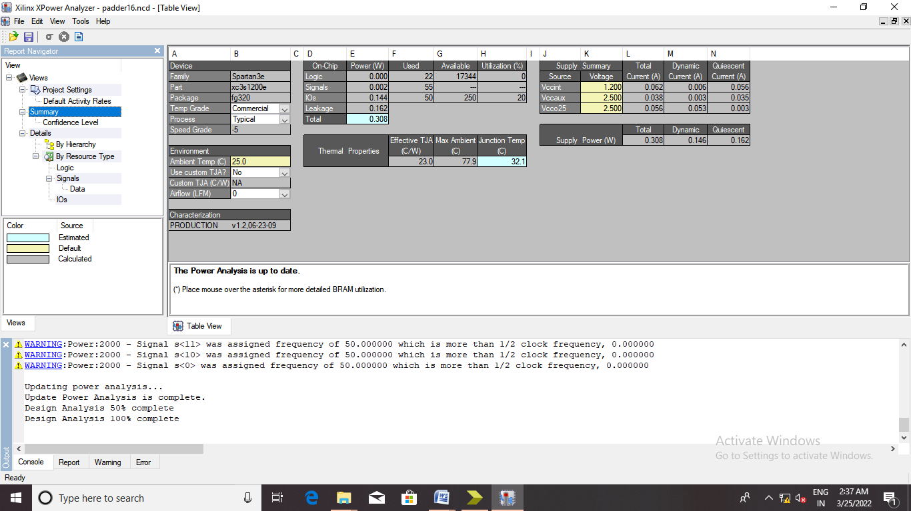
Fig 8.4 Estimation of power
Fig 8.4 Estimates power using approximate multiplier and it is 0.00190W power.
8.1.5 Estimation of Delay:
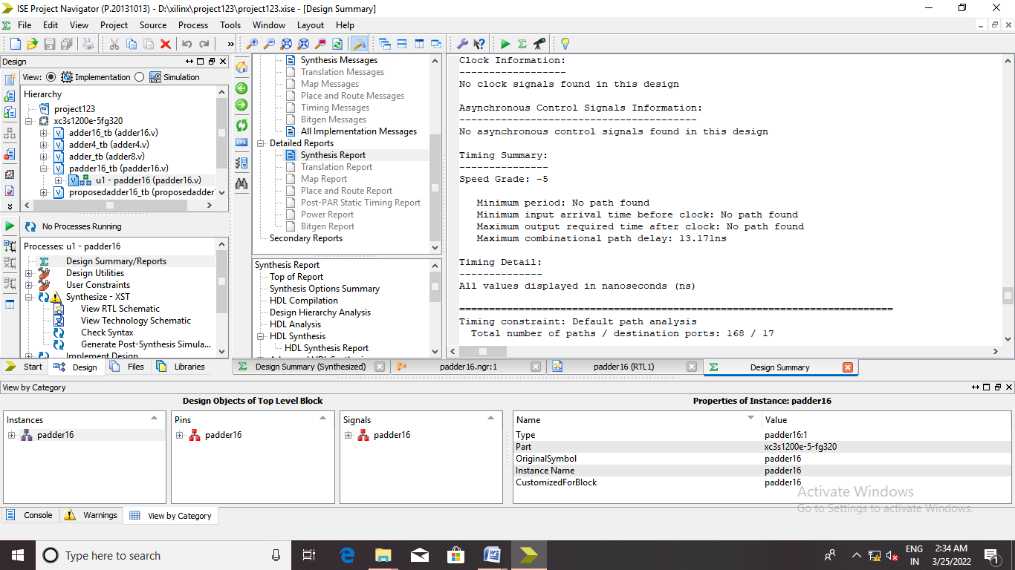
Fig 8.5 Estimation of Delay
Fig 8.5 Estimates delay of approximate multiplier and it is 17.903ns delay.

8.1.6 Estimation of Area:
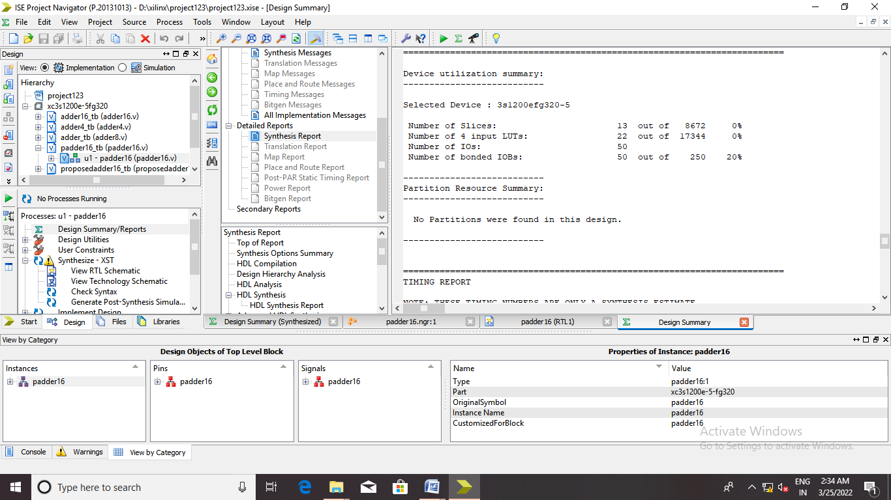
Fig 8.6 Estimation of Area
8.1.7 Synthesis Report:
Table 8.1 Comparison between power and delay

 | EXISTING SYSTEM | PROPOSED SYSTEM
AREA | 29 | 22
DELAY | 18.309ns | 13.18ns
POWER | 0.308 | 0.308
CHAPTER 9-CONCLUSION AND FUTURE SCOPE
9.1 Conclusion:
This work has presented two novel non-volatile and low-power Approximate Magnetic Full Adders (AMFAs), along with an accuracy-adaptive design approach for constructing energy-efficient arithmetic circuits. The proposed AMFAs are tailored to imprecision-tolerant applications, such as image and signal processing, where minor degradation in output quality is acceptable in return for improved performance metrics. Simulation results have demonstrated that the designed adders can achieve power savings of up to 47% while incurring only minimal quality loss—specifically, a 19% reduction in Structural Similarity Index (SSIM) and a 14% reduction in Peak Signal-to-Noise Ratio (PSNR). Furthermore, replacing traditional serial MTJ networks with a parallel configuration has led to a significant reduction in propagation delay—up to 94% lower compared to previous non-volatile magnetic full adders. The circuits also leverage the non-volatility of MTJ devices, allowing complete power shutdown during idle periods without data loss or the need for additional backup mechanisms, thereby greatly reducing leakage and standby power consumption.
9.2 Future Scope:
The proposed adaptive AMFA architecture opens several promising directions for future research and development. One major opportunity lies in extending the design to support wider bit-width arithmetic units, such as 16-bit or 32-bit adders, to accommodate more complex computations while retaining the benefits of adaptability and power efficiency. Additionally, further optimization techniques, including hybrid CMOS-MTJ integration and dynamic precision scaling, can be explored to enhance the energy-quality tradeoff in real-time. Future work can also focus on embedding these adders into larger digital signal processing blocks or neural network accelerators, where power efficiency is critical and small errors are tolerable. Moreover, the integration of learning-based controllers for real-time precision adjustment based on workload conditions could further increase the intelligence and efficiency of approximate computing systems. Overall, the proposed design lays a robust foundation for scalable, intelligent, and energy-aware computing architectures using emerging non-volatile technologies.

BIBLIOGRAPHY
[1] N. S. Kim et al., “Leakage current: Moore’s law meets static power,” Computer, vol. 36, no. 12, pp. 68–75, Dec. 2003.
[2] B. Hoefflinger, “ITRS: The international technology roadmap for semiconductors,” in Chips 2020 (The Frontiers Collection). Sindelfingen, Germany, 2011, pp. 161–174. [Online]. Available: http://www.itrs2. net/2011-itrs.html
[3] W. Zhao, E. Belhaire, C. Chappert, and P. Mazoyer, “Power and area optimization for run-time reconfiguration system on programmable chip based on magnetic random access memory,” IEEE Trans. Magn., vol. 45, no. 2, pp. 776–780, Feb. 2009.
[4] H. Cai, Y. Wang, L. A. De Barros Naviner, and W. Zhao, “Robust ultralow power non-volatile logic-in-memory circuits in FD-SOI technology,” IEEE Trans. Circuits Syst. I, Reg. Papers, vol. 64, no. 4, pp. 847–857, Apr. 2017.
[5] R. Rajaei and S. B. Mamaghani, “A nonvolatile, low-power, and highly reliable MRAM block for advanced microarchitectures,” IEEE Trans. Device Mater. Rel., vol. 17, no. 2, pp. 472–474, Jun. 2017.
[6] G. Pouiklis and G. C. Sirakoulis, “Clock gating methodologies and tools: A survey,” Int. J. Circuit Theory Appl., vol. 44, no. 4, pp. 798–816, Apr. 2016.
[7] A. Amirany and R. Rajaei, “Low power, and highly reliable single event upset immune latch for nanoscale CMOS technologies,” presented at the Iranian Conf. Electr. Eng. (ICEE), 2018.
[8] H. Cai, Y. Wang, L. A. B. Naviner, Z. Wang, and W. Zhao, “Approximate computing in MOS/spintronic non-volatile full-adder,” in Proc. IEEE/ACM Int. Symp. Nanosc. Archit. (NANOARCH), Jul. 2016, pp. 203–208.
[9] A. Amirany and R. Rajaei, “Nonvolatile, spin-based, and low-power inexact full adder circuits for computing-in-memory image processing,” SPIN, vol. 9, no. 3, Sep. 2019, Art. no. 1950013.
[10] V. Gupta, D. Mohapatra, A. Raghunathan, and K. Roy, “Low-power digital signal processing using approximate adders,” IEEE Trans. Comput.-Aided Design Integr. Circuits Syst., vol. 32, no. 1, pp. 124–137, Jan. 2013.
[11] S.-H. Lin, P.-Y. Chen, and Y.-N. Lin, “Hardware design of low-power high-throughput sorting unit,” IEEE Trans. Comput., vol. 66, no. 8, pp. 1383–1395, Aug. 2017.
[12] A. Amirany and R. Rajaei, “Spin-based fully nonvolatile full-adder circuit for computing in memory,” SPIN, vol. 9, no. 1, Mar. 2019, Art. no. 1950007.
[13] H. Jiang, L. Liu, P. P. Jonker, D. G. Elliott, F. Lombardi, and J. Han, “A high-performance and energy-efficient FIR adaptive filter using approximate distributed arithmetic circuits,” IEEE Trans. Circuits Syst. I, Reg. Papers, vol. 66, no. 1, pp. 313–326, Jan. 2019.
[14] P. Sakellariou and V. Paliouras, “Application-specific low-power multipliers,” IEEE Trans. Comput., vol. 65, no. 10, pp. 2973–2985, Oct. 2016.
[15] R. Rajaei and A. Amirany, “Reliable, high-performance, and nonvolatile hybrid SRAM/MRAM-based structures for reconfigurable nanoscale logic devices,” J. Nanoelectron. Optoelectron., vol. 13, no. 9, pp. 1271–1283, Sep. 2018.
[16] V. Jamshidi and M. Fazeli, “Pure magnetic logic circuits: A reliability analysis,” IEEE Trans. Magn., vol. 54, no. 10, pp. 1–10, Oct. 2018.
[17] H. Thapliyal, F. Sharifi, and S. D. Kumar, “Energy-efficient design of hybrid MTJ/CMOS and MTJ/nanoelectronics circuits,” IEEE Trans. Magn., vol. 54, no. 7, pp. 1–8, Jul. 2018.
[18] R. Rajaei and A. Amirany, “Nonvolatile low-cost approximate spintronic full adders for computing in memory architectures,” IEEE Trans. Magn., vol. 56, no. 4, pp. 1–8, Apr. 2020.
[19] W. Wei, K. Namba, Y.-B. Kim, and F. Lombardi, “A novel scheme for tolerating single event/multiple bit upsets (SEU/MBU) in nonvolatile memories,” IEEE Trans. Comput., vol. 65, no. 3, pp. 781–790, Mar. 2016.
[20] A. Amirany and R. Rajaei, “Fully nonvolatile and low power full adder based on spin transfer torque magnetic tunnel junction with spin- Hall effect assistance,” IEEE Trans. Magn., vol. 54, no. 12, pp. 1–7, Dec. 2018.
[21] H. Cai et al., “MRAM-on-FDSOI integration: A bit-cell perspective,” in Proc. IEEE Comput. Soc. Annu. Symp. VLSI (ISVLSI), Jul. 2018, pp. 263–268.
[22] Z. Wang, W. Zhao, E. Deng, J.-O. Klein, and C. Chappert, “Perpendicular-anisotropy magnetic tunnel junction switched by spin- Hall-assisted spin-transfer torque,” J. Phys. D, Appl. Phys., vol. 48, no. 6, Feb. 2015, Art. no. 065001.
[23] J. C. Slonczewski, “Conductance and exchange coupling of two ferromagnets separated by a tunneling barrier,” Phys. Rev. B, Condens. Matter, vol. 39, no. 10, pp. 6995–7002, Apr. 1989.
[24] H. D. Chopra and S. Z. Hua, “Ballistic magnetoresistance over 3000% in Ni nanocontacts at room temperature,” Phys. Rev. B, Condens. Matter, vol. 66, no. 2, Jun. 2002.

